CHAPTER 17
MODEL BUILDING

SECTION EXERCISES
17.1 d/p/e The fifth-order polynomial model would be E(y) = β₀ + β₁x + β₂x² + β₃x³ + β₄x⁴ + β₅x⁵,
a level of complexity that would not be very practical for use with most business data.

17.2 d/p/m The second-order polynomial model is E(y) = β₀ + β₁x + β₂x², and the form of the estimation equation fit to the data would be = b₀ + b₁x + b₂x². Assuming nonnegative values for both x and y,
b₁ > 0 and b₂ < 0 would result in such a curvature. The Excel plot below is an example of such a fitted equation. Note that Excel’s default arrangement of the terms at the right side of the equation is the reverse of what we are used to seeing.
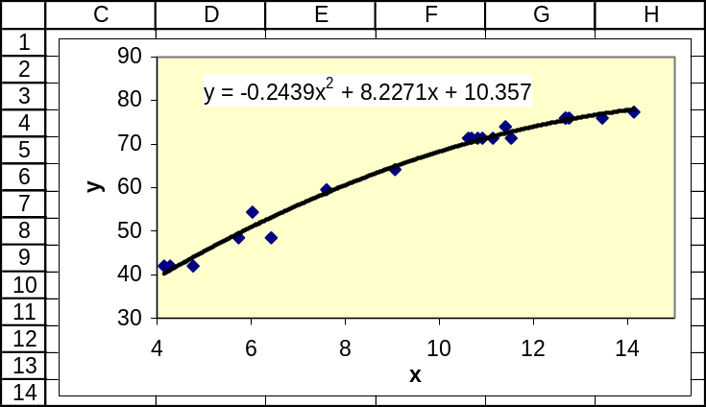

17.3 d/p/m The second-order polynomial model is E(y) = β₀ + β₁x + β₂x², and the form of the estimation equation fit to the data would be = b₀ + b₁x + b₂x². Assuming nonnegative values for both x and y,
b₁ < 0 and b₂ < 0 would result in such a curvature.

17.4 d/p/m The most applicable model for this type of data would be a third-order model. The estimation equation fit to the data would be = b₀ + b₁x + b₂x² + b₃x³. A curvature such as that described for the experimental lubricant could occur if b₁ < 0, b₂ > 0, and b₃ < 0.

17.5 d/p/m With an estimation equation of the form, = b₀ + b₁x + b₂x² + b₃x³, this curvature could be fit if b₁ > 0, b₂ < 0, and b₃ > 0. This is demonstrated in the Excel plot shown below. Note that Excel’s default arrangement of the terms at the right side of the equation is the reverse of what we are used to seeing.
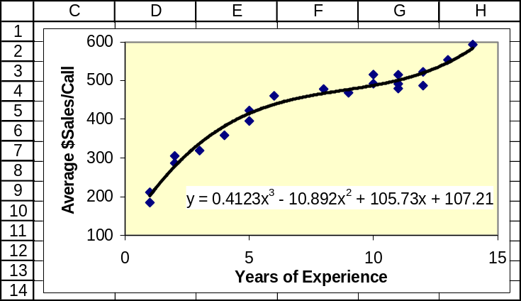
17.6 d/p/m The best-fit equation would be of the form, = b₀ + b₁x + b₂x² + b₃x³, with
b₁ > 0, b₂ < 0, and b₃ > 0. This is demonstrated in the Excel plot shown below.
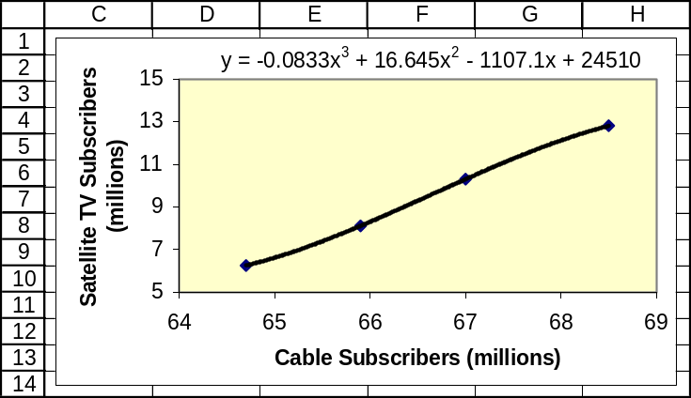

17.7 p/c/m The Minitab and Excel plots are shown below. The estimation equation can be expressed as $AvgRate = 336.094 - 8.239*%Occup + 0.07709*%Occup², and it explains 49.1% of the variation in the average room rates. It is possible that hotels with a lower percentage occupancy might try to attract guests by offering low rates. Also, hotels enjoying a high percentage occupancy may not hesitate to charge the high rates that the market is apparently willing to pay for their rooms.
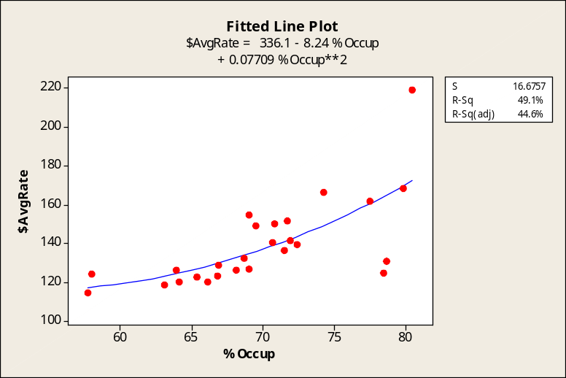
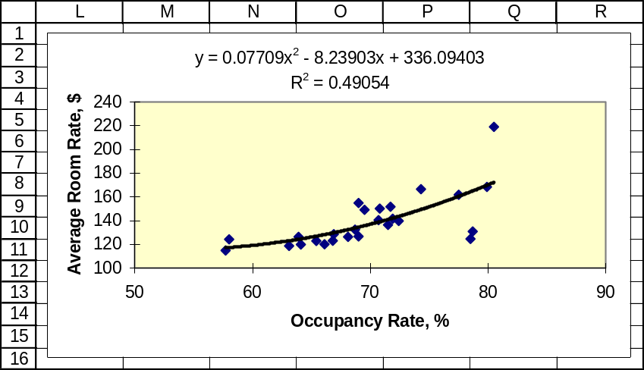
17.8 p/c/m The Minitab plot is shown below. The estimation equation can be expressed as
seconds = 9.728 + 0.05686*yearcode - 0.01714*yearcode². This equation explains 99.5% of the variation in the world record times over the years shown. For 2014, yearcode = 10. Substituting this into the estimation equation, we obtain an estimate of 8.58 seconds. It is highly doubtful that such a record time would be achieved in that year. Unlike most running records, these times are decreasing at an ever-steeper rate. Although the equation is a good fit to these particular five years, we should keep in mind that extrapolating too far beyond the underlying data can be both dangerous and misleading.
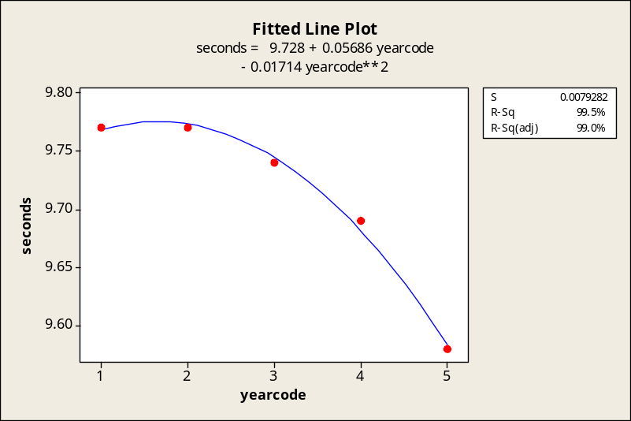

17.9 p/c/m The Minitab printout and the Minitab and Excel plots are shown below. The estimation equation can be expressed as 0-60 Time = 26.8119 - 0.153866*hp+0.0003083*hp². The equation explains 73.8% of the variation in 0-60 times. Substituting hp = 300, a car with 300 horsepower would be estimated as having a 0-60 time of 8.396 seconds. The p-value for the regression (to three decimal places) is 0.000, which is less than the 0.05 level of significance. At this level, the regression is significant.

Regression Analysis: 0-60 versus hp, hpSq

The regression equation is 0-60 = 26.8 - 0.154 hp +0.000308 hpSq

Predictor Coef SE Coef T P
Constant 26.812 2.241 11.97 0.000
hp -0.15387 0.03183 -4.83 0.000
hpSq 0.00030827 0.00008718 3.54 0.002

S = 2.860 R-Sq = 73.8% R-Sq(adj) = 70.9%

Analysis of Variance
Source DF SS MS F P
Regression 2 415.54 207.77 25.39 0.000
Residual Error 18 147.27 8.18
Total 20 562.81

Predicted Values for New Observations
New Obs Fit SE Fit 95.0% CI 95.0% PI
1 8.396 1.418 ( 5.418, 11.375) ( 1.689, 15.104)

Values of Predictors for New Observations
New Obs hp hpSq
1 300 90000

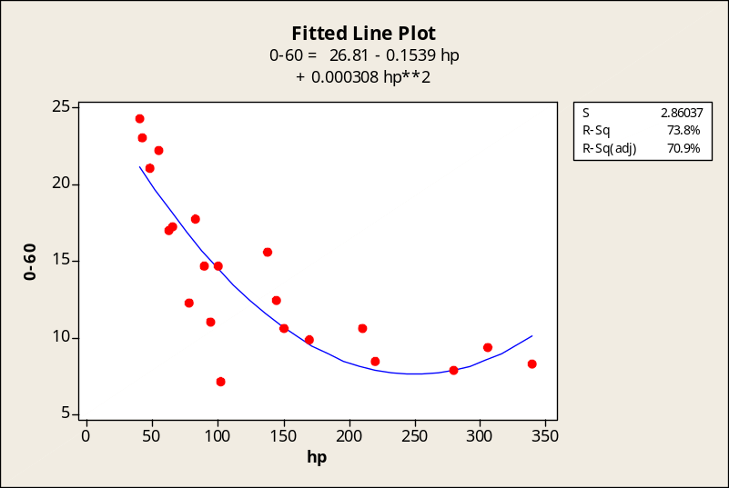

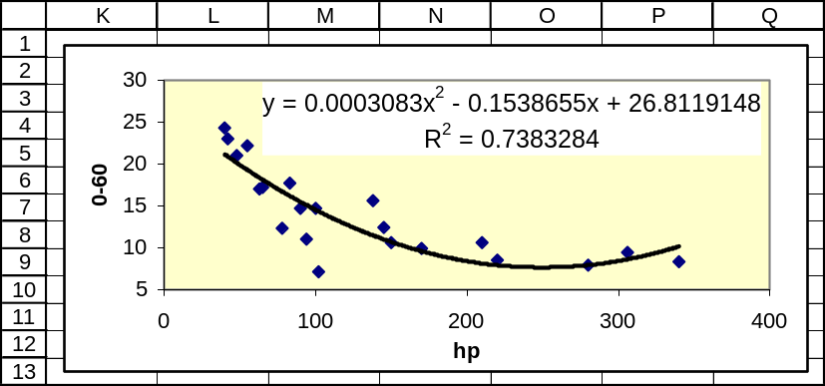

17.10 p/c/m The Minitab printout and plot are shown below. The estimation equation can be expressed as top speed = 59.8231 + 0.665824*hp - 0.0029444*hp² + 0.0000045*hp³.
The equation explains 71.2% of the variation in top speeds. Note that top speed starts out increasing at a decreasing rate. From an automotive engineering standpoint, this is as it should be, considering that horsepower requirement for a given speed is actually a cube (!) function of the speed. However, the three cars with the most horsepower reverse the direction of the curve so that top speed is now increasing as a cube function of the horsepower. The high top speeds of two of the three most powerful cars suggests that they may be producing a lot more horsepower than is being advertised. The car with 170 advertised horsepower with a top speed of 125 mph seems especially guilty of having its horsepower understated.

Polynomial Regression Analysis: topspeed versus hp

The regression equation is topspeed = 59.8231 + 0.665824 hp
- 0.0029444 hp**2 + 0.0000045 hp**3

S = 8.16003 R-Sq = 71.2 % R-Sq(adj) = 66.2 %

Analysis of Variance
Source DF SS MS F P
Regression 3 2804.99 934.997 14.0419 0.000
Error 17 1131.96 66.586
Total 20 3936.95

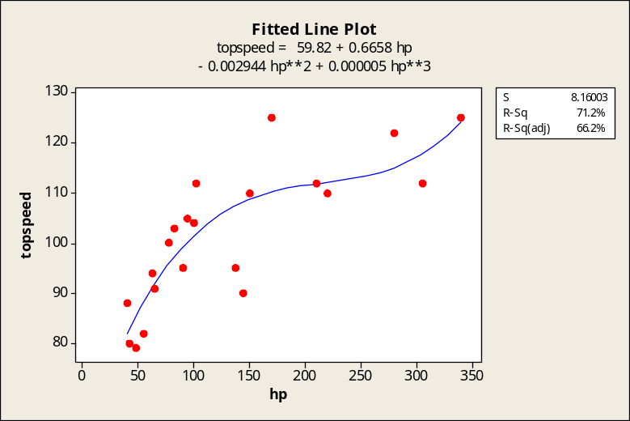

17.11 p/c/m Given only the information in the Excel printout, the estimation equation can be expressed as ForGross = 860.8444 - 4.1517*DomGross + 0.0077*DomGross².
For a film with domestic gross ticket sales of $400 million, the estimated foreign gross ticket sales will be
ForGross = 860.8444 - 4.1517(400) + 0.0077(400)² = $432.16 million.
The regression is significant at the 0.05 level, since p-value = 0.00000471 is < 0.05 level of significance. Note that the Excel p-value is shown as 4.71E-06, scientific notation for 4.71(10)⁻⁶.
A more accurate calculation can be made if the constant and coefficients in the estimation equation are not limited to four decimal places. The Minitab printout is shown below. As shown in the “Fit” column of the printout, a film with $400 million in domestic gross ticket sales would be predicted to generate $430.4 million in foreign gross ticket sales.

Regression Analysis: ForGross versus DomGross, DomGross_sq

The regression equation is
ForGross = 861 - 4.15 DomGross + 0.00769 DomGross_sq

Predictor Coef SE Coef T P
Constant 860.8 245.0 3.51 0.003
DomGross -4.152 1.439 -2.88 0.010
DomGross 0.007689 0.001920 4.00 0.001

S = 112.6 R-Sq = 76.4% R-Sq(adj) = 73.6%

Analysis of Variance
Source DF SS MS F P
Regression 2 697099 348550 27.49 0.000
Residual Error 17 215552 12680
Total 19 912651

New Obs Fit SE Fit 95.0% CI 95.0% PI
1 430.4 44.7 ( 336.1, 524.7) ( 174.8, 686.0)

Values of Predictors for New Observations
New Obs DomGross DomGross
1 400 160000

17.12 d/p/m The most suitable model would be a first-order model with two predictor variables, or
E(y) = β₀ + β₁x₁ + β₂x₂.

17.13 d/p/m The most suitable model would be a second-order model with interaction, or
E(y) = β₀ + β₁x₁ + β₂x₂ + β₃x₁² + β₄x₂² + β₅x₁x₂.

17.14 d/p/m If x₂ = 10, a 1-unit increase in x₁ will increase by 5 units. If x₂ = 20, a 1-unit increase in x₁ will increase by 5 units. Regardless of the value of x₂, a 1-unit increase in x₁ will increase by 5 units. In this model, there is no interaction between x₁ and x₂.

17.15 p/c/m The second-order model with interaction is E(y) = β₀ + β₁x₁ + β₂x₂ + β₃x₁² + β₄x₂² + β₅x₁x₂. Minitab has been used to obtain the estimation equation and printout shown below.

Regression Analysis: Avg$/call versus Yrs, Score, ...

The regression equation is
Avg$/call = 61 + 25.6 Yrs + 6.41 Score - 1.82 Yrs_sq - 0.058 Score_sq
+ 0.29 Yrs*Score

Predictor Coef SE Coef T P
Constant 61.2 132.2 0.46 0.651
Yrs 25.63 31.58 0.81 0.431
Score 6.409 8.174 0.78 0.446
Yrs_sq -1.817 2.700 -0.67 0.512
Score_sq -0.0582 0.1288 -0.45 0.658
Yrs*Scor 0.295 1.087 0.27 0.790

S = 29.85 R-Sq = 94.9% R-Sq(adj) = 93.1%

Analysis of Variance
Source DF SS MS F P
Regression 5 233075 46615 52.32 0.000
Residual Error 14 12473 891
Total 19 245548

The estimation equation is Avg$/call = 61 + 25.6*Yrs + 6.41*Score - 1.82*Yrs² - 0.058*Score² + 0.29*Yrs*Score. As a decimal fraction, R² = 0.949, and 94.9% of the variation in average dollar sales per call is explained by the equation. Since p-value = 0.000 is < 0.05 level of significance, the model is significant at this level.

17.16 p/c/m
a. Minitab has been used to obtain the estimation equation and printout shown below.

Regression Analysis: Revenue versus Cars, Locations

The regression equation is Revenue = 7.4 + 11.7 Cars - 0.148 Locations

Predictor Coef SE Coef T P
Constant 7.40 60.61 0.12 0.905
Cars 11.7061 0.6004 19.50 0.000
Location -0.14785 0.07941 -1.86 0.087

S = 156.8 R-Sq = 98.4% R-Sq(adj) = 98.1%

Analysis of Variance
Source DF SS MS F P
Regression 2 17889902 8944951 363.84 0.000
Residual Error 12 295019 24585
Total 14 18184920
As a decimal fraction, R² = 0.984, and 98.4% of the variation in revenue is explained by the equation.
Since p-value = 0.000 is < 0.01 level of significance, the model is significant at this level.

b. Repeating part (a), but with an interaction term included, we obtain the printout below.

Regression Analysis: Revenue versus Cars, Locations, Cars*Locs

The regression equation is
Revenue = - 65.2 + 12.3 Cars - 0.051 Locations -0.000505 Cars*Locs

Predictor Coef SE Coef T P
Constant -65.15 83.31 -0.78 0.451
Cars 12.3359 0.7766 15.88 0.000
Location -0.0505 0.1104 -0.46 0.656
Cars*Loc -0.0005050 0.0004074 -1.24 0.241

S = 153.4 R-Sq = 98.6% R-Sq(adj) = 98.2%

Analysis of Variance
Source DF SS MS F P
Regression 3 17926066 5975355 253.92 0.000
Residual Error 11 258854 23532
Total 14 18184920
As a decimal fraction, R² = has increased very slightly, from 0.984 to 0.986, and 98.6% of the variation in revenue is explained by the new equation. Since p-value = 0.000 is < 0.01 level of significance, the model is significant at this level.

17.17 p/c/m
a. Minitab has been used to obtain the estimation equation and printout shown below.

Regression Analysis: OpRevenue versus Employees, Departures
The regression equation is OpRevenue = - 231 + 0.129 Employees + 0.00565 Departures

Predictor Coef SE Coef T P
Constant -231.2 345.7 -0.67 0.511
Employee 0.12883 0.01277 10.09 0.000
Departur 0.005649 0.001243 4.55 0.000

S = 1220 R-Sq = 95.8% R-Sq(adj) = 95.4%

Analysis of Variance
Source DF SS MS F P
Regression 2 681281501 340640751 228.93 0.000
Residual Error 20 29759807 1487990
Total 22 711041308
As a decimal fraction, R² = 0.958, and 95.8% of the variation in operating revenue is explained by the equation. Since p-value = 0.000 is < 0.01 level of significance, the model is significant at this level.

b. Repeating part (a), but with an interaction term included, we obtain the printout below.

Regression Analysis: OpRevenue versus Employees, Departures, Emps*Deps
The regression equation is
OpRevenue = 399 + 0.0745 Employees + 0.00087 Departures +0.000000 Emps*Deps

Predictor Coef SE Coef T P
Constant 399.2 230.2 1.73 0.099
Employee 0.07453 0.01169 6.38 0.000
Departur 0.000874 0.001075 0.81 0.427
Emps*Dep 0.00000014 0.00000002 6.12 0.000

S = 726.3 R-Sq = 98.6% R-Sq(adj) = 98.4%

Analysis of Variance
Source DF SS MS F P
Regression 3 701019585 233673195 443.02 0.000
Residual Error 19 10021724 527459
Total 22 711041308
We find R² has increased from 0.958 to 0.986, and 98.6% of the variation in operating revenue is explained by the new equation. Since p-value = 0.000 is < the 0.01 level, the model is significant.
17.18 p/c/m
a. Minitab has been used to obtain the estimation equation and printout shown below.

Regression Analysis: OpRevenue versus Aircraft, Employees

The regression equation is
OpRevenue = - 455 + 16.3 Aircraft + 0.0654 Employees

Predictor Coef SE Coef T P
Constant -454.8 386.7 -1.18 0.253
Aircraft 16.298 3.911 4.17 0.000
Employee 0.06539 0.02723 2.40 0.026

S = 1273 R-Sq = 95.4% R-Sq(adj) = 95.0%

Analysis of Variance
Source DF SS MS F P
Regression 2 678652444 339326222 209.53 0.000
Residual Error 20 32388865 1619443
Total 22 711041308
As a decimal fraction, R² = 0.954, and 95.4% of the variation in operating revenue is explained by the equation. Since p-value = 0.000 is < 0.01 level of significance, the model is significant at this level.

b. Repeating part (a), but with an interaction term included, we obtain the printout below.

Regression Analysis: OpRevenue versus Aircraft, Employees, AirCr*Emps

The regression equation is
OpRevenue = - 291 + 17.1 Aircraft + 0.0183 Employees +0.000070 AirCr*Emps

Predictor Coef SE Coef T P
Constant -291.5 435.0 -0.67 0.511
Aircraft 17.142 4.065 4.22 0.000
Employee 0.01826 0.06227 0.29 0.773
AirCr*Em 0.00007024 0.00008329 0.84 0.410

S = 1282 R-Sq = 95.6% R-Sq(adj) = 94.9%

Analysis of Variance
Source DF SS MS F P
Regression 3 679820959 226606986 137.91 0.000
Residual Error 19 31220349 1643176
Total 22 711041308
As a decimal fraction, R² = has increased very slightly, from 0.954 to 0.956, and 95.6% of the variation in operating revenue is explained by the new equation. Since p-value = 0.000 is < 0.01 level of significance, the model is significant at this level.

17.19 p/c/m Minitab has been used to obtain the estimation equation and printout shown below.

Regression Analysis: 0-60 versus hp, curbwt, hp*curbwt

The regression equation is
0-60 = 25.4 - 0.161 hp - 0.00030 curbwt +0.000028 hp*curbwt

Predictor Coef SE Coef T P
Constant 25.419 4.338 5.86 0.000
hp -0.16109 0.03551 -4.54 0.000
curbwt -0.000302 0.002233 -0.14 0.894
hp*curbw 0.00002818 0.00000946 2.98 0.008

S = 2.968 R-Sq = 73.4% R-Sq(adj) = 68.7%

Analysis of Variance
Source DF SS MS F P
Regression 3 413.09 137.70 15.64 0.000
Residual Error 17 149.71 8.81
Total 20 562.81

As a decimal fraction, R² = 0.734, and 73.4% of the variation in 0-60 mph time is explained by the equation. Since p-value = 0.000 is < 0.02 level of significance, the model is significant at this level.

17.20 p/c/m Repeating exercise 17.19, but using a second-order model with interaction:

Regression Analysis: 0-60 versus hp, curbwt, hpSq, curbwtSq, hp*curbwt

The regression equation is
0-60 = 1.29 - 0.351 hp + 0.0306 curbwt +0.000142 hpSq -0.000008 curbwtSq
+0.000087 hp*curbwt

Predictor Coef SE Coef T P
Constant 1.291 9.013 0.14 0.888
hp -0.35115 0.08216 -4.27 0.001
curbwt 0.03061 0.01129 2.71 0.016
hpSq 0.0001421 0.0002967 0.48 0.639
curbwtSq -0.00000796 0.00000351 -2.27 0.038
hp*curbw 0.00008676 0.00005556 1.56 0.139

S = 2.428 R-Sq = 84.3% R-Sq(adj) = 79.1%

Analysis of Variance
Source DF SS MS F P
Regression 5 474.391 94.878 16.10 0.000
Residual Error 15 88.416 5.894
Total 20 562.807

As a decimal fraction, R² has increased from 0.734 to 0.843, and 84.3% of the variation in 0-60 mph time is explained by the equation. Since p-value = 0.000 is < 0.02 level of significance, the model is significant at this level.

17.21 p/p/m There will be two independent variables and the format for the linear regression equation for estimating the dollar amount of the order will be
Dollars = b₀ + b₁*Minutes + b₂*Visa
The coding of the qualitative variable: Visa = 1 if customer used a Visa card, otherwise = 0.

17.22 p/p/m Although we have three types of credit cards (Visa, MasterCard, and other), this information can be represented by only two qualitative variables. The equation will have this form:
Dollars = b₀ + b₁*Minutes + b₂*Visa + b₃*MasterCard
The coding of the two qualitative variables: Visa = 1 if customer used Visa card, otherwise = 0;
and MasterCard = 1 if customer used MasterCard, otherwise = 0. For example, the data for a customer who spent $40 during a 20-minute visit to the site and used MasterCard could be listed as 40, 20, 0, and 1. If the same customer had used a card other than Visa or MasterCard, her data could have been listed as 40, 20, 0, and 0.

17.23 p/p/m There are three risk levels (low, medium, and high), so this information can be represented by just two qualitative variables. If the two variables are named Low and Medium:
For a person who specifies low risk, Low = 1 and Medium = 0.
For a person who specifies medium risk, Low = 0 and Medium = 1.
For a person who specifies high risk, Low = 0 and Medium = 0.

17.24 p/p/m There are now four risk levels (low, medium, high, and very high), so this information can be represented by just three qualitative variables. If the three variables are named Low, Medium, and High:
For a person who specifies low risk, Low = 1, Medium = 0, and High = 0.
For a person who specifies medium risk, Low = 0, Medium = 1, and High = 0.
For a person who specifies high risk, Low = 0, Medium = 0, and High = 1.
For a person who specifies very high risk, Low = 0, Medium = 0, and High = 0.

17.25 p/p/m Given that the estimated number of customers is 150 + 5x₁ + 50x₂: For each additional
one-degree increase in the high temperature, the estimated number of customers would increase by 5.
If the day happens to fall on a weekend (Saturday or Sunday), the estimated number of customers would increase by 50. The estimated number of customers on an 80-degree Saturday would be
150 + 5(80) + 50(1) = 600.

17.26 p/p/m The partial regression coefficient for x₁ (LSAT score) is 0.1 -- on average, each additional point on the LSAT exam tends to be accompanied by an increase of $0.1 thousand in starting salary.
The partial regression coefficient for x₂ (Sector) is 30. Sector is coded 1 if graduate joins private sector and 0 if graduate joins public sector -- thus, on average, graduates who join the private sector tend to have a starting salary that is $30 thousand higher than those who join the public sector.
The estimated starting salary for a new graduate with an LSAT score of 160 who is entering the private sector will be 50 + 0.1(160) + 30(1) = $96 thousand.

17.27 p/c/m Minitab has been used to obtain the estimation equation and printout shown below.

Regression Analysis: Price versus GB, 7200rpm?

The regression equation is Price = - 30.8 + 4.97 GB + 54.2 7200rpm?

Predictor Coef SE Coef T P
Constant -30.77 54.89 -0.56 0.593
GB 4.975 1.140 4.36 0.003
7200rpm? 54.20 44.11 1.23 0.259

S = 66.39 R-Sq = 79.0% R-Sq(adj) = 73.0%

Analysis of Variance
Source DF SS MS F P
Regression 2 115899 57949 13.15 0.004
Residual Error 7 30851 4407
Total 9 146750

The regression equation is Price = - 30.77 + 4.975*GB + 54.20*7200rpm?. The partial regression coefficient for GB is 4.975 -- for a given rotational speed, an additional gigabyte of storage capacity would tend to raise the price by $4.975. The partial regression coefficient for the qualitative variable 7200rpm? is 54.20 -- for a given level of storage capacity, a drive with the higher rotational speed would tend to be priced $54.20 higher than one with the lower rotational speed.

The corresponding Excel printout is shown below.
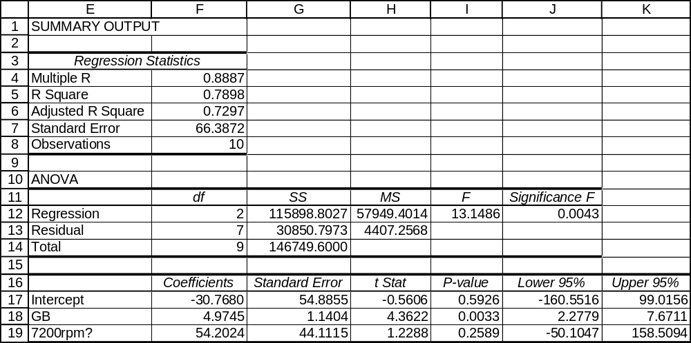
17.28 p/c/m Minitab has been used to obtain the estimation equation and printout shown below.

Regression Analysis: Amount versus Seconds, Female?

The regression equation is Amount = 90.1 - 0.781 Seconds + 15.3 Female?

Predictor Coef SE Coef T P
Constant 90.12 17.12 5.26 0.000
Seconds -0.7813 0.4503 -1.73 0.089
Female? 15.266 7.093 2.15 0.037

S = 24.53 R-Sq = 12.6% R-Sq(adj) = 8.9%

Analysis of Variance
Source DF SS MS F P
Regression 2 4068.1 2034.1 3.38 0.042
Residual Error 47 28279.9 601.7
Total 49 32348.0

The regression equation is Amount = 90.12 - 0.7813*Seconds + 15.266*Female?. The partial regression coefficient for Seconds is -0.7813 -- for a given gender, an additional second at the machine tends to reduce the withdrawal amount by $0.7813. The partial regression coefficient for the qualitative variable Female? is 15.266 -- for a given number of seconds at the machine, a female will tend to withdraw $15.266 more than a male.

17.29 p/c/d We must first devise a coding scheme for the assembly methods, then enter the data into the computer. Since there are three possible assembly methods, there will be two qualitative variables in the regression: MethA? and MethB?. If the unit was assembled by method A, then MethA? = 1 and
MethB? = 0. If the unit was assembled by method B, them MethA? = 0 and MethB? = 1. If the unit was assembled by method C (i.e., by neither method A nor method B), MethA? = 0 and MethB? = 0.
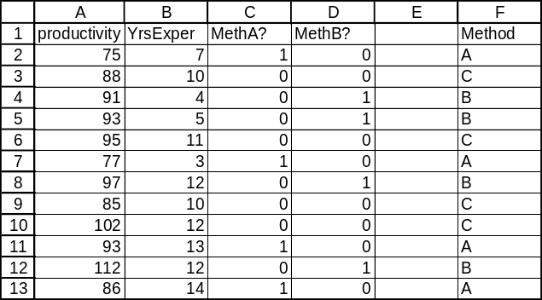

The Minitab printout is shown below.

Regression Analysis: productivity versus YrsExper, MethA?, MethB?

The regression equation is
productivity = 75.4 + 1.59 YrsExper - 7.36 MethA? + 9.73 MethB?

Predictor Coef SE Coef T P
Constant 75.369 6.307 11.95 0.000
YrsExper 1.5936 0.5139 3.10 0.015
MethA? -7.360 4.372 -1.68 0.131
MethB? 9.734 4.491 2.17 0.062

S = 6.086 R-Sq = 74.1% R-Sq(adj) = 64.4%

Analysis of Variance
Source DF SS MS F P
Regression 3 847.33 282.44 7.63 0.010
Residual Error 8 296.33 37.04
Total 11 1143.67
The regression equation is productivity = 75.369 + 1.5936*YrsExper - 7.360*MethA? + 9.734*MethB?.
The equation explains 74.1% of the variation in productivity. The partial regression coefficient for years of experience is 1.5936 -- for a given assembly method, an additional year of experience tends to increase productivity by 1.5936 units per hour. The interpretations of the other partial regression coefficients are as follows:
For a given number of years of experience, using method A tends to reduce productivity by 7.360 units per hour compared to method C.
For a given number of years of experience, using method B tends to increase productivity by 9.734 units per hour compared to method C.

The corresponding Excel printout is shown below.
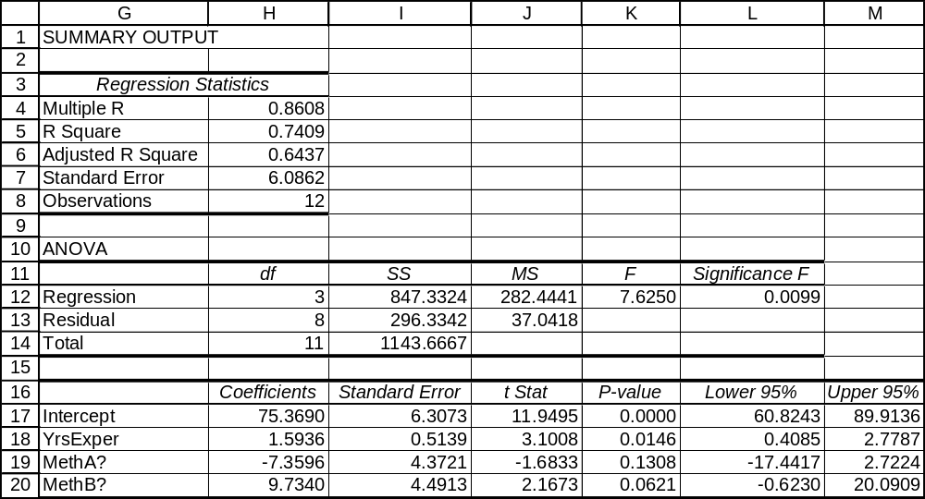

17.30 p/c/d We must first devise a coding scheme for the suburban areas, then enter the data into the computer. Since there are three possible suburban areas, there will be two qualitative variables in the regression: Sunny? and Easy?. For a home in Sunny Haven, Sunny? = 1 and Easy? = 0. For a home in Easy Acres, Sunny? = 0 and Easy? = 1. For a home in Rolling Hills, Sunny? = 0 and Easy? = 0.
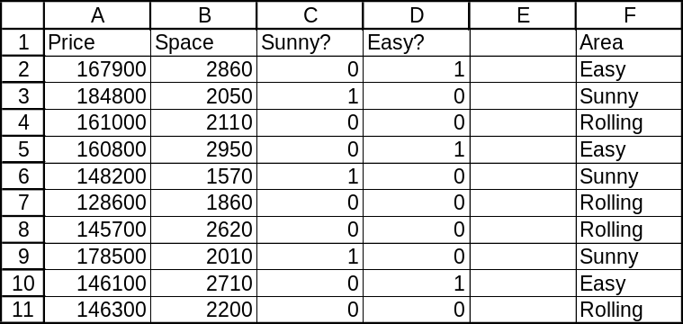

The Minitab printout is shown below.

Regression Analysis: Price versus Space, Sunny?, Easy?

The regression equation is Price = 66744 + 35.8 Space + 36584 Sunny? - 10131 Easy?

Predictor Coef SE Coef T P
Constant 66744 40456 1.65 0.150
Space 35.79 18.19 1.97 0.097
Sunny? 36584 11181 3.27 0.017
Easy? -10131 15085 -0.67 0.527

S = 12488 R-Sq = 64.4% R-Sq(adj) = 46.6%

Analysis of Variance
Source DF SS MS F P
Regression 3 1693235619 564411873 3.62 0.084
Residual Error 6 935653381 155942230
Total 9 2628889000

The regression equation is Price = 66,744 + 35.79*Space + 36,584*Sunny? - 10,131*Easy?.
The equation explains 64.4% of the variation in price. The partial regression coefficient for Space is
35.79 -- for a given location, an additional square foot of living space will tend to cost $35.79.
The interpretations of the other partial regression coefficients are as follows:
For a given amount of living space, a home in Sunny Haven will tend to cost $36,584 more than a home in Rolling Hills.
For a given amount of living space, a home in Easy Acres will tend to cost $10,131 less than a home in Rolling Hills.

The corresponding Excel printout is shown below.
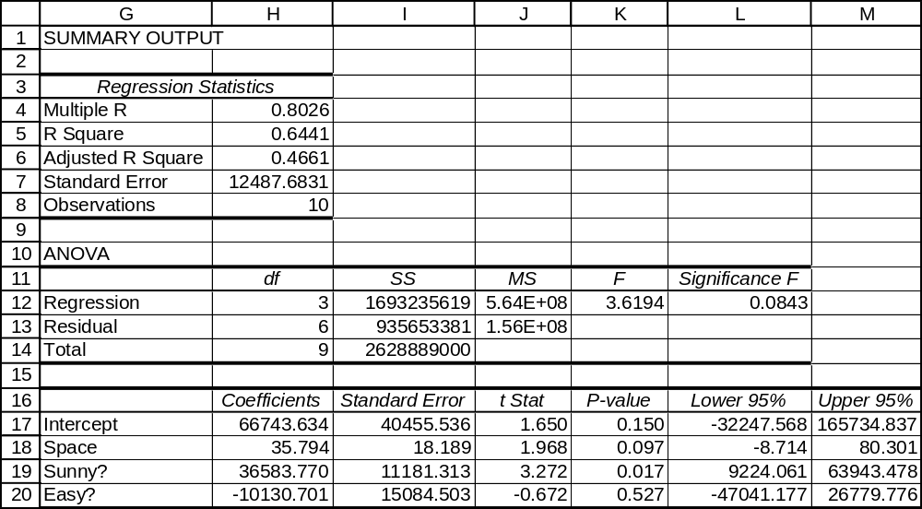

17.31 c/a/m When we are converting the exponential estimation equation, 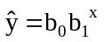, to linear form,
the result can be expressed as log = log b₀ + x log b₁ .
In this problem, the conversion is reversed, and we can express the given equation as
log = -0.179 + x 0.140.
Since log b₀ = -0.179, then b₀ = 10^{-0.179}, or 0.66. Since log b₁ = 0.140, then b₁ = 10^{0.140}, or 1.38.
The exponential form of the equation is = 0.66(1.38)^{x}.
17.32 c/a/m When we are converting the multiplicative estimation equation, 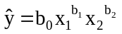,
to linear form, the result can be expressed as log = log b₀ + b₁ log x₁ + b₂ log x₂ .
In this problem, the conversion is reversed, and the given equation is
log = 3.15 + 0.473 log x₁ + 0.354 log x₂ .
Since log b₀ = 3.15, then b₀ = 10^{3.15}, or 1412.54. With b₁ = 0.473 and b₂ = 0.354, the multiplicative form of the equation is 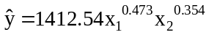.

17.33 p/c/m We first use Excel to fit the equation = 42.668371e^{0.0168x} to the data.
Since e = 2.71828, e^{0.0168} = 1.0169419, and we can express the equation as = 42.668371(1.0169419)^{x}.
To three decimal places, R² = 0.496. For a market in which the average occupancy rate is x = 70 percent, the estimated average room rate would be = 42.668371(1.0169419)⁷⁰, or $138.30.

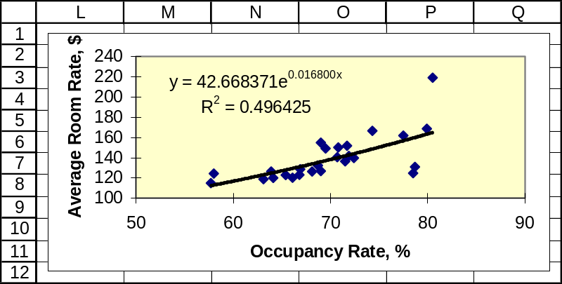

17.34 p/c/m We first use Excel to fit the equation = 9.849091e^{-0.00475x} to the data.
Since e = 2.71828, e^{-0.00475} = 0.995261, and we can express the equation as
= 9.849091(0.995261)^{x}. To three decimal places, R² = 0.832.
For the year 2014, the year code is x = 10, and the estimated world record time for
the 100-meter dash will be = 9.849091(0.995261)¹⁰ = 9.39 seconds.

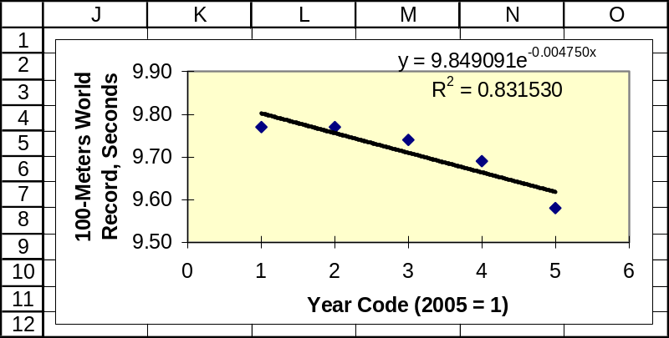

17.35 p/c/m Using Minitab, we transform the data so that we have the corresponding logarithm to the base 10, then perform a multiple regression using the transformed data. (As noted in exercise 17.17, operating revenue is expressed in millions of dollars.) The printout is shown below.

Regression Analysis: logRev versus logEmps, logDeps

The regression equation is logRev = - 0.128 + 1.00 logEmps - 0.112 logDeps

Predictor Coef SE Coef T P
Constant -0.1285 0.2285 -0.56 0.580
logEmps 1.00396 0.09668 10.38 0.000
logDeps -0.11212 0.07542 -1.49 0.153

S = 0.2112 R-Sq = 92.8% R-Sq(adj) = 92.0%

Analysis of Variance
Source DF SS MS F P
Regression 2 11.4312 5.7156 128.14 0.000
Residual Error 20 0.8921 0.0446
Total 22 12.3233

The equation and the result when it is converted back to multiplicative form are shown below:
Logarithmic form: log Revenue = -0.1285 + 1.0040*log Employees - 0.1121*log Departures
Multiplicative form: Revenue = 0.7439*Employees^{1.0040} *Departures ^{-0.1121} .
The estimated total operating revenue for an airline with 2000 employees and 10,000 departures would be 0.7439*(2000)^{1.0040} *(10,000)^{-0.1121} = $546.2 million.

17.36 p/c/m Using Minitab, we transform the data so that we have the corresponding logarithm to the base 10, then perform a multiple regression using the transformed data. (As noted in exercise 17.16, rental revenue is expressed in millions of dollars and the number of cars is expressed in thousands.) The printout is shown below.

Regression Analysis: logRev versus logCars, logLocats

The regression equation is logRev = 0.777 + 1.16 logCars - 0.0369 logLocats

Predictor Coef SE Coef T P
Constant 0.7765 0.1743 4.46 0.001
logCars 1.16039 0.07012 16.55 0.000
logLocat -0.03692 0.08056 -0.46 0.655

S = 0.1092 R-Sq = 97.3% R-Sq(adj) = 96.9%

Analysis of Variance
Source DF SS MS F P
Regression 2 5.1613 2.5807 216.60 0.000
Residual Error 12 0.1430 0.0119
Total 14 5.3043

The equation and the result when it is converted back to multiplicative form are shown below:
Logarithmic form: log Revenue = 0.7765 + 1.16039*log Cars - 0.03692*log Locations
Multiplicative form: Revenue = 5.9772*Cars^{1.16039} *Locations^{-0.03692} .
The estimated rental revenue for a company with 80 thousand cars in service and 2500 rental locations would be 5.9772*(80)^{1.16039} *(2500)^{-0.03692} = $723.39 million.

17.37 d/p/m A correlation matrix is a matrix that shows the correlation of each variable in a multiple regression analysis with each of the other variables. A high correlation between two independent variables is an indication of multicollinearity.

17.38 d/p/m Multicollinearity is a situation in which two or more of the independent variables in a multiple regression are highly correlated with each other. When this happens, the two correlated x variables are really not saying different things about y. The standard errors for the partial regression coefficients become very large and the coefficients are statistically unreliable and difficult to interpret. Multicollinearity is a problem when we are trying to interpret the partial regression coefficients.
There are several clues to the presence of multicollinearity: (1) an independent variable known to be an important predictor ends up having a partial regression coefficient that is not significant;
(2) a partial regression coefficient exhibits the wrong sign; and/or, (3) when an independent variable is added or deleted, the partial regression coefficients for the other variables change dramatically.
A more practical way to identify multicollinearity is through the examination of a correlation matrix, which is a matrix that shows the correlation of each variable with each of the other variables. A high correlation between two independent variables is an indication of multicollinearity.

17.39 d/p/m Multicollinearity is a problem when we are trying to interpret the partial regression coefficients. Multicollinearity is not a problem when we are simply substituting x values into the regression equation in order to estimate y.

17.40 d/p/m This situation would suggest that multicollinearity is present. The partial regression coefficient for x₁ is rather unstable. Besides changing in apparent importance from the first regression to the second, it has even changed signs.

17.41 d/p/m There is a very strong correlation (0.952) between predictor variables x₁ and x₃, suggesting the presence of multicollinearity.

17.42 p/c/m The Minitab and Excel correlation results are shown below. There is a strong correlation between the number of cars and the number of locations, and multicollinearity could be a problem.

Correlations: Cars, Locations

Pearson correlation of Cars and Locations = 0.739
P-Value = 0.002

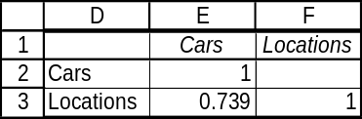

17.43 p/c/m The Minitab and Excel correlation results are shown below. There are strong correlations between the pairs of independent variables, indicating that multicollinearity could be a problem.

Correlations: Aircraft, Employees, Departures

Aircraft Employee
Employee 0.948
0.000

Departur 0.872 0.761
0.000 0.000

Cell Contents: Pearson correlation
P-Value

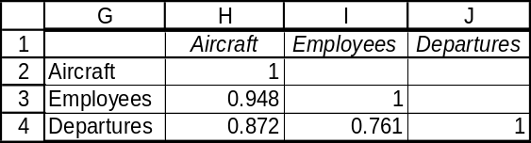

17.44 p/c/m The Minitab and Excel correlation results are shown below. The positive correlation between daily morning circulation and daily evening circulation is moderately strong, with a p-value of 0.069, so multicollinearity could pose a slight problem here.

Correlations: DailyMor, DailyEve

Pearson correlation of DailyMor and DailyEve = 0.631
P-Value = 0.069

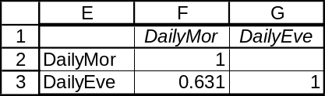

17.45 p/c/m The Minitab and Excel correlation results are shown below. The correlations between the independent variables are very weak, indicating that multicollinearity should not be a problem.

Correlations: CrudeOil, NatGas, Coal

CrudeOil NatGas
NatGas 0.018
0.957

Coal -0.159 0.225
0.640 0.506

Cell Contents: Pearson correlation
P-Value

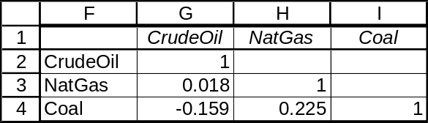

17.46 d/p/m Stepwise regression is a multiple regression estimation technique whereby independent variables are added to the regression equation one at a time. The first x variable to enter the regression is the one that explains the greatest amount of variation in y. The second variable to enter is the one that explains the greatest amount of the remaining variation. The use of stepwise regression can reduce the possibility of multicollinearity since it is unlikely that two highly correlated x variables will be included in a multiple regression that is estimated using the stepwise technique. This technique is useful when there are a great many independent variables.

17.47 d/p/m Independent variables are selected for entry into the equation during stepwise regression based upon the amount of the remaining variation in y (the variation that has not already been explained by included variables) that a candidate variable can explain.

17.48 d/p/m Predictor variable x₉ will not necessarily be the next variable brought into the equation.
We do not know about the correlation between x₄ and x₉, so we cannot determine whether x₉ will explain the greatest amount of the remaining variation in y.

17.49 c/a/m
a. The first variable included in the equation is x₅. This is followed (in order) by x₂ and x₉.
b. The multiple regression equation after two independent variables have been introduced is:
= 106.85 - 0.35x₅ - 0.33x₂. This equation explains 19.66% of the total variation in y, and the multiple standard error of the estimate is 13.2.
c. The p-values for the tests of the partial regression coefficient x₅, x₂, and x₉ are 0.026, 0.010, and 0.044, respectively. At the 0.05 level, the partial regression coefficients for all three independent variables differ significantly from 0. At the 0.02 level, only the coefficient for x₂ differs significantly from 0.

17.50 p/c/m The correlation matrix for all of the variables is shown below, followed by the results of the conventional and stepwise regression analyses.

Correlations: Sunday, DailyMor, DailyEve

Sunday DailyMor
DailyMor 0.864
0.003
DailyEve 0.931 0.631
0.000 0.069
Cell Contents: Pearson correlation
P-Value

Regression Analysis: Sunday versus DailyMor, DailyEve

The regression equation is Sunday = - 35.5 + 1.71 DailyMor + 1.67 DailyEve

Predictor Coef SE Coef T P
Constant -35.549 6.435 -5.52 0.001
DailyMor 1.7113 0.1500 11.41 0.000
DailyEve 1.6680 0.1044 15.97 0.000

S = 0.271393 R-Sq = 99.4% R-Sq(adj) = 99.2%

Analysis of Variance
Source DF SS MS F P
Regression 2 75.234 37.617 510.72 0.000
Residual Error 6 0.442 0.074
Total 8 75.676

Stepwise Regression: Sunday versus DailyMor, DailyEve

Alpha-to-Enter: 0.05 Alpha-to-Remove: 0.1
Response is Sunday on 2 predictors, with N = 9
Step 1 2
Constant 37.48 -35.55

DailyEve 2.42 1.67
T-Value 6.77 15.97
P-Value 0.000 0.000

DailyMor 1.71
T-Value 11.41
P-Value 0.000

S 1.20 0.271
R-Sq 86.75 99.42
R-Sq(adj) 84.86 99.22
Mallows Cp 131.1 3.0

In the conventional regression analysis, the two independent variables explain 99.4% of the variation in Sunday circulation. In the stepwise regression, both independent variables were introduced and the total explained variation was the same. In the stepwise regression, daily evening circulation was the first independent variable introduced, and it alone explained 86.75% of the variation in Sunday circulation.

17.51 p/c/m The correlation matrix for all of the variables is shown below, followed by the results of the conventional and stepwise regression analyses.

Correlations: Total_Energy, CrudeOil, NatGas, Coal

Total_Energy CrudeOil NatGas
CrudeOil 0.410
0.210

NatGas 0.815 0.018
0.002 0.957

Coal 0.508 -0.159 0.225
0.110 0.640 0.506

Cell Contents: Pearson correlation
P-Value

Regression Analysis: Total_Energy versus CrudeOil, NatGas, Coal

The regression equation is Total_Energy = 15.4 + 0.576 CrudeOil + 1.12 NatGas + 0.781 Coal

Predictor Coef SE Coef T P
Constant 15.407 2.487 6.20 0.000
CrudeOil 0.57602 0.05791 9.95 0.000
NatGas 1.12087 0.07452 15.04 0.000
Coal 0.78136 0.08862 8.82 0.000

S = 0.159090 R-Sq = 98.5% R-Sq(adj) = 97.9%

Analysis of Variance
Source DF SS MS F P
Regression 3 11.7727 3.9242 155.05 0.000
Residual Error 7 0.1772 0.0253
Total 10 11.9499

Stepwise Regression: Total_Energy versus CrudeOil, NatGas, Coal

Alpha-to-Enter: 0.05 Alpha-to-Remove: 0.1
Response is Total_Energy on 3 predictors, with N = 11

Step 1 2 3
Constant 36.73 31.23 15.41

NatGas 1.284 1.272 1.121
T-Value 4.22 5.39 15.04
P-Value 0.002 0.001 0.000

CrudeOil 0.490 0.576
T-Value 2.64 9.95
P-Value 0.030 0.000

Coal 0.781
T-Value 8.82
P-Value 0.000

S 0.668 0.518 0.159
R-Sq 66.42 82.05 98.52
R-Sq(adj) 62.69 77.56 97.88
Mallows Cp 151.6 79.7 4.0

All three independent variables were introduced during the stepwise regression. Natural gas had the strongest correlation with the dependent variable, so it was the first variable to enter the equation during the stepwise procedure. In both regression procedures, all three independent variables explained 98.5% of the variation in total energy production. In the stepwise regression, natural gas and crude oil, the first two of the three variables introduced, explained 82.05% of the variation in total energy production.

17.52 p/c/m The correlation matrix for the variables is shown below, followed by the results of the conventional and stepwise regression analyses.

Correlations: Revenue, Cars, Locations

Revenue Cars
Cars 0.989
0.000

Location 0.685 0.739
0.005 0.002

Cell Contents: Pearson correlation
P-Value

Regression Analysis: Revenue versus Cars, Locations

The regression equation is Revenue = 7.4 + 11.7 Cars - 0.148 Locations

Predictor Coef SE Coef T P
Constant 7.40 60.61 0.12 0.905
Cars 11.7061 0.6004 19.50 0.000
Location -0.14785 0.07941 -1.86 0.087

S = 156.8 R-Sq = 98.4% R-Sq(adj) = 98.1%

Analysis of Variance
Source DF SS MS F P
Regression 2 17889902 8944951 363.84 0.000
Residual Error 12 295019 24585
Total 14 18184920

Stepwise Regression: Revenue versus Cars, Locations

Alpha-to-Enter: 0.05 Alpha-to-Remove: 0.1

Response is Revenue on 2 predictors, with N = 15

Step 1
Constant -33.81

Cars 10.88
T-Value 24.67
P-Value 0.000

S 171
R-Sq 97.91
R-Sq(adj) 97.75
C-p 4.5

In the conventional regression analysis, the two independent variables explain 98.4% of the variation in revenue. The number of cars in service had the highest correlation with revenue, and it was the first and only variable introduced in the stepwise regression. The regression equation with number of cars as the only independent variable explains 97.91% of the variation in revenue.

17.53 p/c/m The correlation matrix for the variables is shown below, followed by the results of the conventional and stepwise regression analyses.

Correlations: Avg$/call, Yrs, Score

Avg$/cal Yrs
Yrs 0.945
0.000

Score 0.930 0.940
0.000 0.000

Cell Contents: Pearson correlation
P-Value

Regression Analysis: Avg$/call versus Yrs, Score

The regression equation is Avg$/call = 192 + 16.0 Yrs + 1.88 Score

Predictor Coef SE Coef T P
Constant 192.27 34.20 5.62 0.000
Yrs 15.991 5.690 2.81 0.012
Score 1.882 1.146 1.64 0.119

S = 36.58 R-Sq = 90.7% R-Sq(adj) = 89.6%

Analysis of Variance
Source DF SS MS F P
Regression 2 222805 111402 83.27 0.000
Residual Error 17 22743 1338
Total 19 245548

Stepwise Regression: Avg$/call versus Yrs, Score

Alpha-to-Enter: 0.05 Alpha-to-Remove: 0.1

Response is Avg$/cal on 2 predictors, with N = 20

Step 1
Constant 241.3

Yrs 24.8
T-Value 12.24
P-Value 0.000

S 38.3
R-Sq 89.27
R-Sq(adj) 88.67
C-p 3.7

In the conventional regression analysis, the two independent variables explain 90.7% of the variation in average dollar sales per call. The number of years of experience had the highest correlation with the dependent variable, and it was the first and only variable introduced in the stepwise regression.
The regression equation with number of years of experience as the only independent variable explains 89.27% of the variation in average dollar sales per call.

17.54 p/c/m The correlation matrix for all of the variables is shown below, followed by the results of the conventional and stepwise regression analyses.

Correlations: OpRevenue, Aircraft, Employees, Departures

OpRevenu Aircraft Employee
Aircraft 0.970
0.000

Employee 0.957 0.948
0.000 0.000

Departur 0.863 0.872 0.761
0.000 0.000 0.000

Cell Contents: Pearson correlation
P-Value

Regression Analysis: OpRevenue versus Aircraft, Employees, Departures

The regression equation is
OpRevenue = - 434 + 8.28 Aircraft + 0.0897 Employees + 0.00365 Departures

Predictor Coef SE Coef T P
Constant -434.5 357.9 -1.21 0.240
Aircraft 8.285 5.273 1.57 0.133
Employee 0.08974 0.02776 3.23 0.004
Departur 0.003651 0.001748 2.09 0.050

S = 1177 R-Sq = 96.3% R-Sq(adj) = 95.7%

Analysis of Variance
Source DF SS MS F P
Regression 3 684702829 228234276 164.64 0.000
Residual Error 19 26338480 1386236
Total 22 711041308

Stepwise Regression: OpRevenue versus Aircraft, Employees, Departures

Alpha-to-Enter: 0.05 Alpha-to-Remove: 0.1

Response is OpRevenu on 3 predictors, with N = 23

Step 1 2
Constant -737.8 -454.8

Aircraft 25.2 16.3
T-Value 18.35 4.17
P-Value 0.000 0.000

Employee 0.065
T-Value 2.40
P-Value 0.026

S 1410 1273
R-Sq 94.13 95.44
R-Sq(adj) 93.85 94.99
C-p 11.1 6.4

Only two of the three independent variables were introduced during the stepwise regression. Aircraft was the independent variable with the strongest correlation with the dependent variable, and it was the first variable to enter the equation during the stepwise regression. The two independent variables in the stepwise regression explain 95.44% of the variation in operating revenue, slightly less than the 96.3% explained by all three independent variables in the conventional multiple regression.

17.55 p/c/m
a. The correlation matrix shows that Memb7 and Memb8 are tied for being the most highly correlated with the overall rating. Note that Memb7 and Memb8 are also highly correlated with each other.

Correlations: Overall, Memb1, Memb2, Memb3, Memb4, Memb5, Memb6, Memb7, Memb8, M

Overall Memb1 Memb2 Memb3 Memb4 Memb5 Memb6 Memb7
Memb1 0.868
Memb2 0.843 0.709
Memb3 0.839 0.745 0.707
Memb4 0.895 0.704 0.719 0.725
Memb5 0.907 0.816 0.745 0.612 0.792
Memb6 0.889 0.810 0.649 0.710 0.795 0.788
Memb7 0.924 0.744 0.790 0.764 0.863 0.808 0.758
Memb8 0.924 0.714 0.725 0.778 0.852 0.838 0.846 0.830
Memb9 0.885 0.720 0.741 0.702 0.725 0.779 0.759 0.825

Memb8
Memb9 0.772

Cell Contents: Pearson correlation

b. The stepwise regression is shown below. We would expect either Memb7 or Memb8 to be the first variable brought in.

Stepwise Regression: Overall versus Memb1, Memb2, ...

Alpha-to-Enter: 0.05 Alpha-to-Remove: 0.1

Response is Overall on 9 predictors, with N = 28

Step 1 2 3 4 5 6 7
Constant 4.3600 -1.7404 -0.4649 -2.0891 -1.9432 -2.7894 -1.7702

Memb7 0.961 0.611 0.457 0.288 0.230 0.198 0.137
T-Value 12.36 7.72 6.20 5.49 5.00 5.21 4.03
P-Value 0.000 0.000 0.000 0.000 0.000 0.000 0.001

Memb6 0.432 0.312 0.213 0.189 0.205 0.176
T-Value 5.82 4.72 4.92 5.23 6.95 7.23
P-Value 0.000 0.000 0.000 0.000 0.000 0.000

Memb5 0.254 0.301 0.274 0.244 0.228
T-Value 3.97 7.54 8.17 8.64 10.10
P-Value 0.001 0.000 0.000 0.000 0.000

Memb3 0.231 0.216 0.191 0.182
T-Value 6.39 7.26 7.62 9.18
P-Value 0.000 0.000 0.000 0.000

Memb9 0.119 0.104 0.120
T-Value 3.51 3.77 5.42
P-Value 0.002 0.001 0.000

Memb2 0.095 0.092
T-Value 3.59 4.46
P-Value 0.002 0.000

Memb4 0.086
T-Value 3.76
P-Value 0.001

S 3.31 2.20 1.75 1.07 0.876 0.706 0.553
R-Sq 85.46 93.82 96.27 98.66 99.14 99.47 99.69
R-Sq(adj) 84.90 93.33 95.81 98.42 98.94 99.31 99.58
C-p 2693.1 1132.3 676.7 232.8 144.8 85.7 46.4

Step 8 9
Constant -1.432 -1.220

Memb7 0.135 0.132
T-Value 4.40 6.62
P-Value 0.000 0.000

Memb6 0.160 0.114
T-Value 7.00 6.56
P-Value 0.000 0.000

Memb5 0.209 0.152
T-Value 9.61 8.47
P-Value 0.000 0.000

Memb3 0.166 0.123
T-Value 8.75 8.25
P-Value 0.000 0.000

Memb9 0.119 0.126
T-Value 5.99 9.70
P-Value 0.000 0.000

Memb2 0.094 0.089
T-Value 5.05 7.27
P-Value 0.000 0.000

Memb4 0.073 0.081
T-Value 3.43 5.84
P-Value 0.003 0.000

Memb8 0.061 0.108
T-Value 2.39 5.73
P-Value 0.027 0.000

Memb1 0.090
T-Value 5.18
P-Value 0.000

S 0.498 0.324
R-Sq 99.76 99.90
R-Sq(adj) 99.66 99.86
C-p 34.9 10.0

c. From the results given in part b, it appears that the board could be reduced to four or five members without a tremendous loss in rating power. The coefficient of multiple determination for the regression using four board members is 0.9866; using five board members, it increases to 0.9914.
d. The following estimates the regression using only the data provided by board members 7 and 6.
These were the first two board members introduced in the stepwise regression. Except for rounding, this equation is identical with the one in step two of the stepwise regression. The same holds for the t-ratios, p-values, and coefficients of multiple determination. Thus, the stepwise technique and the multiple regression technique yield the same results when using the same variables.

Regression Analysis: Overall versus Memb7, Memb6

The regression equation is Overall = - 1.74 + 0.611 Memb7 + 0.432 Memb6

Predictor Coef SE Coef T P
Constant -1.740 4.032 -0.43 0.670
Memb7 0.61140 0.07923 7.72 0.000
Memb6 0.43151 0.07417 5.82 0.000
S = 2.202 R-Sq = 93.8% R-Sq(adj) = 93.3%

Analysis of Variance
Source DF SS MS F P
Regression 2 1840.60 920.30 189.88 0.000
Residual Error 25 121.17 4.85
Total 27 1961.77
17.56 p/c/d
a. Stepwise regression with the rating from board member 1 as the dependent variable and the ratings by the other 8 members as the set of independent variables from which to select.

Stepwise Regression: Memb1 versus Memb2, Memb3, ...

Alpha-to-Enter: 0.05 Alpha-to-Remove: 0.1

Response is Memb1 on 8 predictors, with N = 28

Step 1 2
Constant 18.746 5.327

Memb5 0.75 0.53
T-Value 7.20 4.67
P-Value 0.000 0.000

Memb3 0.38
T-Value 3.19
P-Value 0.004

S 5.42 4.66
R-Sq 66.58 76.26
R-Sq(adj) 65.30 74.36
C-p 17.6 7.5

It is no surprise that Memb5 is brought in first, since it had the highest correlation with Memb1.
(See the correlation matrix in the solution to exercise 17.55.) The final equation is:
Memb1 = 5.327 + 0.53*Memb5 + 0.38*Memb3
The partial regression coefficient for Memb5 implies that, holding the rating from the third board member constant, a one point increase in the rating from the fifth member will tend to result in a 0.53 point increase in the rating from the first member. The partial regression coefficient for Memb3 implies that, holding the rating from the fifth board member constant, a one point increase in the rating from the third board member will tend to result in a 0.38 point increase in the rating from the first board member. This regression equation explains 76.26% of the variation in ratings from the first board member.

b. Multiple regression estimating Memb1 based on Memb5 and Memb3.

Regression Analysis: Memb1 versus Memb5, Memb3

The regression equation is Memb1 = 5.33 + 0.528 Memb5 + 0.383 Memb3

Predictor Coef SE Coef T P
Constant 5.327 8.016 0.66 0.512
Memb5 0.5280 0.1131 4.67 0.000
Memb3 0.3830 0.1199 3.19 0.004

S = 4.660 R-Sq = 76.3% R-Sq(adj) = 74.4%

Analysis of Variance
Source DF SS MS F P
Regression 2 1744.04 872.02 40.16 0.000
Residual Error 25 542.82 21.71
Total 27 2286.86

c. Except for slight differences due to rounding, the results of the multiple regression in part b are the same as those provided by step two of the stepwise regression in part a.

17.57 p/c/d
a. Stepwise regression with the rating from board member 9 as the dependent variable and the ratings by the other 8 members as the set of independent variables from which to select.

Stepwise Regression: Memb9 versus Memb1, Memb2, ...

Alpha-to-Enter: 0.05 Alpha-to-Remove: 0.1

Response is Memb9 on 8 predictors, with N = 28

Step 1
Constant 3.551

Memb7 0.98
T-Value 7.45
P-Value 0.000

S 5.61
R-Sq 68.11
R-Sq(adj) 66.88
C-p 0.9

Only one variable is included in this regression, Memb7. It is not surprising that
Memb7 enters in step one, because it had the highest correlation with Memb9. (See the
correlation matrix in exercise 17.55.) However, no additional variables are included.
The final regression equation is Memb9 = 3.551 + 0.98*Memb7.
The partial regression coefficient for board member 7 indicates that a one point increase in the rating from member 7 will tend to result in a 0.98 point increase in the rating from member 9.
The standard error of the estimate for this regression is 5.61, and the coefficient of determination is 0.6811.

b. Regression estimating Memb9 based on Memb7.

Regression Analysis: Memb9 versus Memb7

The regression equation is Memb9 = 3.55 + 0.980 Memb7

Predictor Coef SE Coef T P
Constant 3.551 9.914 0.36 0.723
Memb7 0.9803 0.1316 7.45 0.000

S = 5.606 R-Sq = 68.1% R-Sq(adj) = 66.9%

Analysis of Variance

Source DF SS MS F P
Regression 1 1744.9 1744.9 55.52 0.000
Residual Error 26 817.1 31.4
Total 27 2562.0

c. Except for slight differences due to rounding, the results of the regression in part b are the same as those provided by step two of the stepwise regression in part a.

CHAPTER EXERCISES
17.58 p/c/m The second-order polynomial model shown below is a very good fit to the data. The equation is CD% = 87.684 + 1.5375x - 0.26726x². The model explains 86.80% of the variation in CD music percentage. For 2015, the year code will be x = 16 and the predicted CD music percentage for that year will be 43.865%, as shown in the “Fit” column of the Minitab printout below.

Regression Analysis: CD% versus x, x_sq

The regression equation is CD% = 87.7 + 1.54 x - 0.267 x_sq
Predictor Coef SE Coef T P
Constant 87.684 1.607 54.56 0.000
x 1.5375 0.8194 1.88 0.119
x_sq -0.26726 0.08888 -3.01 0.030

S = 1.15198 R-Sq = 86.8% R-Sq(adj) = 81.5%

Analysis of Variance
Source DF SS MS F P
Regression 2 43.633 21.817 16.44 0.006
Residual Error 5 6.635 1.327
Total 7 50.269

Predicted Values for New Observations
New
Obs Fit SE Fit 95% CI 95% PI
1 43.865 11.478 (14.359, 73.371) (14.211, 73.519)XX
XX denotes a point that is an extreme outlier in the predictors.

Values of Predictors for New Observations
New
Obs x x_sq
1 16.0 256

17.59 p/c/m The third-order polynomial model is a fairly good fit to the data. The equation is
Pages = -141.5 + 422.5x - 61.01x² + 2.749x³, and it explains 82.7% of the variation in page count. However, it would be unwise to use this equation to predict the page count in a book published in 2015. For 2015, the year code is x = 18 and the prediction for a Harry Potter book published that year would be an incredible 3727 pages. It can be dangerous to extrapolate too far beyond the underlying data.

Regression Analysis: Pages versus x, xSq, xCubed

The regression equation is Pages = - 141 + 422 x - 61.0 xSq + 2.75 xCubed

Predictor Coef SE Coef T P
Constant -141.5 291.6 -0.49 0.661
x 422.5 231.6 1.82 0.166
xSq -61.01 47.10 -1.30 0.286
xCubed 2.749 2.766 0.99 0.394

S = 130.620 R-Sq = 82.7% R-Sq(adj) = 65.5%

Analysis of Variance
Source DF SS MS F P
Regression 3 245215 81738 4.79 0.115
Residual Error 3 51185 17062
Total 6 296399

Predicted Values for New Observations
New
Obs Fit SE Fit 95% CI 95% PI
1 3727.0 4842.8 (-11685.0, 19138.9) (-11690.6, 19144.5)XX
XX denotes a point that is an extreme outlier in the predictors.

Values of Predictors for New Observations
New
Obs x xSq xCubed
1 18.0 324 5832

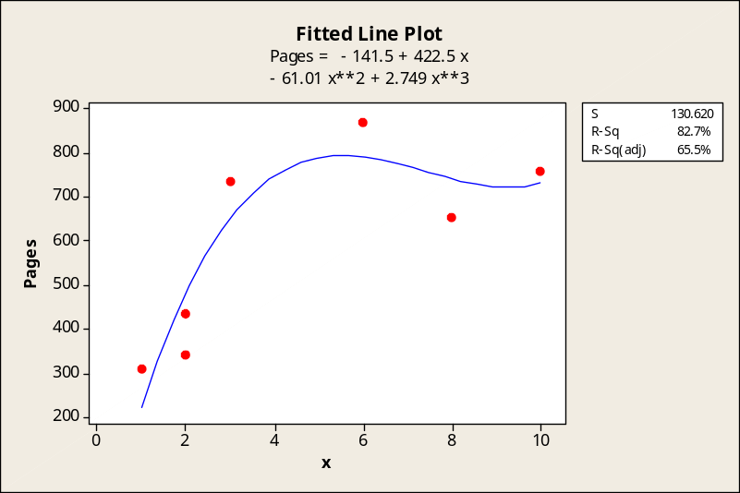

17.60 p/c/m The second-order polynomial model shown below is a good fit to the data.
The equation is Investments = -0.34351 + 0.00253*Deals + 0.00001*Deals². There is a strong direct relationship between the variables. The number of deals explains 97.9% of the variation in venture capital investment amounts. If we were to fit a third-order model to the data, the percentage of variation explained would increase only slightly, to 98.0%.
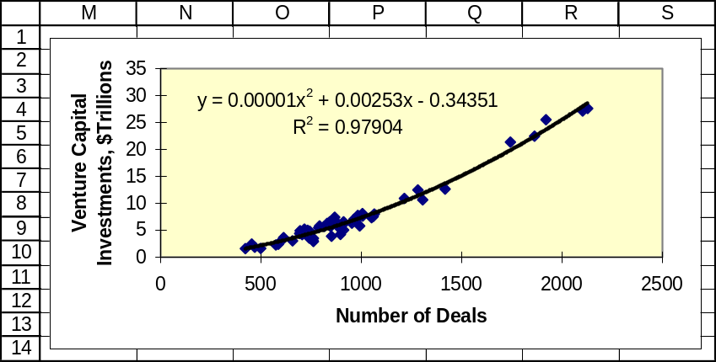

17.61 p/c/m The second-order polynomial model shown below is a good fit to the data.
The equation is Productivity = 10.705 + 0.974*Backlog - 0.015*Backlog².
The size of the backlog explains 83.6% of the variation in productivity. If we were to fit a third-order model to the data, the percentage of variation explained would increase only slightly, to 84.0%.
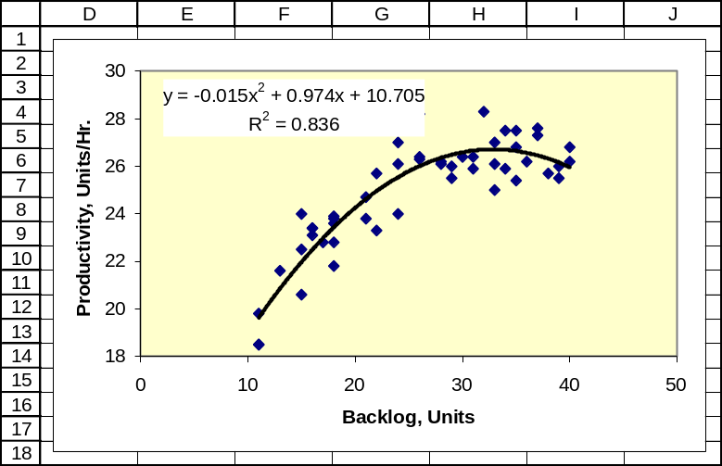

17.62 p/c/m The third-order polynomial model is a reasonably good fit to the data. The equation is
Years to Spread = 249.9 - 5.216*YearCode + 0.04108*YearCode² - 0.0001076*YearCode³. Using this model, the year code explains 64.5% of the variation in the number of years an invention takes to spread to 25% of the U.S. population.
For an innovation invented in 2015, the year code would be 215 and the estimate would be -41.47 years, as shown in the Minitab printout below. It would be impossible for an invention to spread to one-fourth of the U.S. population 41.47 years before it was even invented, and this result is yet another example of the dangers of extrapolating too far beyond the data on which the model was developed.

Regression Analysis: Yrs_to_25% versus YearCode, YearCode_sq, ...

The regression equation is
Yrs_to_25% = 250 - 5.22 YearCode + 0.0411 YearCode_sq - 0.000108 YearCode_cubed

Predictor Coef SE Coef T P
Constant 249.9 201.1 1.24 0.269
YearCode -5.216 5.190 -1.01 0.361
YearCode_sq 0.04108 0.04221 0.97 0.375
YearCode_cubed -0.0001076 0.0001095 -0.98 0.371

S = 10.3571 R-Sq = 64.5% R-Sq(adj) = 43.2%

Analysis of Variance
Source DF SS MS F P
Regression 3 975.7 325.2 3.03 0.132
Residual Error 5 536.3 107.3
Total 8 1512.0

Predicted Values for New Observations
New
Obs Fit SE Fit 95% CI 95% PI
1 -41.47 53.62 (-179.31, 96.37) (-181.86, 98.92)XX
XX denotes a point that is an extreme outlier in the predictors.

Values of Predictors for New Observations
New
Obs YearCode YearCode_sq YearCode_cubed
1 215 46225 9938375

The corresponding Excel plot and equation. Note: If we had fit a second-order model, the R² value would have been just 0.577, or 57.7%, so the third-order model is a worthwhile improvement.
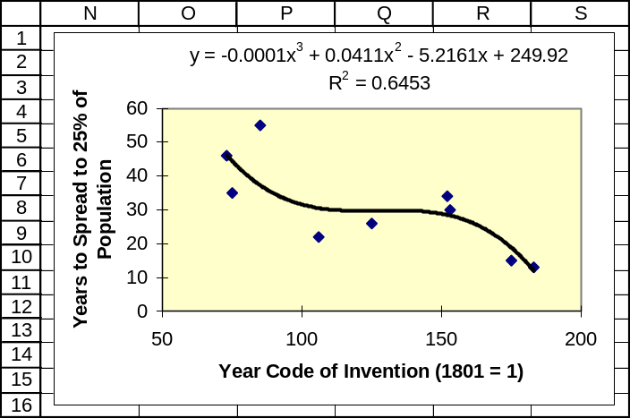

17.63 p/c/m The first-order polynomial estimation equation is shown below. The partial regression coefficient for temperature is 1.32. For a given level of wind speed, a one degree increase in temperature will tend to result in a 1.32 degree increase in the wind chill index – i.e., we will tend to “feel” 1.32 degrees warmer. The partial regression coefficient for wind speed is -0.456. For a given temperature, a one mph increase in the wind speed will tend to lower the wind chill index by 0.456, making us feel like it is 0.456 degrees colder. The equation explains 99.5% of the variation in wind chill index values.

Regression Analysis: Wchill versus Temp, Wind

The regression equation is Wchill = - 11.3 + 1.32 Temp - 0.456 Wind

Predictor Coef SE Coef T P
Constant -11.2963 0.4097 -27.58 0.000
Temp 1.32048 0.00870 151.76 0.000
Wind -0.45600 0.01456 -31.32 0.000

S = 2.18392 R-Sq = 99.5% R-Sq(adj) = 99.4%

Analysis of Variance
Source DF SS MS F P
Regression 2 114529 57264 12006.39 0.000
Residual Error 132 630 5
Total 134 115159

The first-order polynomial estimation equation with interaction term is shown below. By including the interaction term, we have increased the explanatory power of the equation from R² = 0.995
to R² = 0.997, or from 99.5% to 99.7% of the variation in wind chill index values.

Regression Analysis: Wchill versus Temp, Wind, TempxWind

The regression equation is Wchill = - 11.3 + 1.18 Temp - 0.456 Wind + 0.00542 TempxWind

Predictor Coef SE Coef T P
Constant -11.2963 0.2937 -38.46 0.000
Temp 1.18500 0.01360 87.15 0.000
Wind -0.45600 0.01044 -43.68 0.000
TempxWind 0.0054190 0.0004833 11.21 0.000

S = 1.56593 R-Sq = 99.7% R-Sq(adj) = 99.7%

Analysis of Variance
Source DF SS MS F P
Regression 3 114837 38279 15610.50 0.000
Residual Error 131 321 2
Total 134 115159
17.64 p/c/m The first-order polynomial estimation equation is shown below. The partial regression coefficient for percent of consumer credit cards overdue is 1.01. For a given percentage of residential loans overdue, an increase of one percentage point in consumer credit cards overdue will tend to result in an increase of 1.01 percentage points in all insured commercial bank loans that are overdue. The partial regression coefficient for percent of residential loans overdue is 0.038. For a given percentage of consumer credit cards overdue, an increase of one percentage point in residential loans overdue will tend to result in an increase of 0.038 percentage points in all insured commercial bank loans that are overdue. The equation explains 94.1% of the variation in percentage of all insured commercial bank loans that are overdue.

Regression Analysis: AllLoans_% versus CredCard_%, Resid_%

The regression equation is AllLoans_% = - 2.36 + 1.01 CredCard_% + 0.038 Resid_%

Predictor Coef SE Coef T P
Constant -2.3570 0.5056 -4.66 0.006
CredCard_% 1.0084 0.1448 6.96 0.001
Resid_% 0.0384 0.1625 0.24 0.823

S = 0.124527 R-Sq = 94.1% R-Sq(adj) = 91.8%

Analysis of Variance
Source DF SS MS F P
Regression 2 1.24335 0.62168 40.09 0.001
Residual Error 5 0.07753 0.01551
Total 7 1.32089

The first-order polynomial equation with interaction term is shown below. By including the interaction term, we have increased the explanatory power of the equation from R² = 0.941 to R² = 0.943, or from 94.1% to 94.3% of the variation in the percentage of insured commercial bank loans overdue.
The increase in model complexity has made only a very slight improvement in R².

Regression Analysis: AllLoans_% versus CredCard_%, Resid_%, CredCardxRes

The regression equation is
AllLoans_% = - 0.49 + 0.56 CredCard_% - 0.92 Resid_% + 0.228 CredCardxResid

Predictor Coef SE Coef T P
Constant -0.494 4.797 -0.10 0.923
CredCard_% 0.560 1.157 0.48 0.654
Resid_% -0.917 2.450 -0.37 0.727
CredCardxResid 0.2277 0.5823 0.39 0.716

S = 0.136638 R-Sq = 94.3% R-Sq(adj) = 90.1%

Analysis of Variance
Source DF SS MS F P
Regression 3 1.24621 0.41540 22.25 0.006
Residual Error 4 0.07468 0.01867
Total 7 1.32089

17.65 p/c/m
The first-order polynomial estimation equation is shown below. The partial regression coefficient for backlog size is 0.211. For a given gender, an increase of one unit in the backlog size will tend to result in an increase of 0.211 units/hour in productivity. The partial regression coefficient for being a female is 0.577. For a given backlog size, a female will tend to have a productivity that is 0.577 units/hour higher. The R² value is 0.676, and the equation explains 67.6% of the variation in productivity. To three decimal places, the p-value for the overall relationship is 0.000. This is less than the 0.02 level of significance, so at this level the model is significant.

Regression Analysis: productivity versus backlogsize, female

The regression equation is productivity = 19.1 + 0.211 backlogsize + 0.577 female

Predictor Coef SE Coef T P
Constant 19.0897 0.6153 31.02 0.000
backlogs 0.21108 0.02197 9.61 0.000
female 0.5774 0.3863 1.49 0.142

S = 1.360 R-Sq = 67.6% R-Sq(adj) = 66.2%

Analysis of Variance
Source DF SS MS F P
Regression 2 181.440 90.720 49.08 0.000
Residual Error 47 86.882 1.849
Total 49 268.322

17.66 p/c/m In the Minitab printout below, the partial regression coefficient for age is -0.352.
With the other independent variables unchanged, a one year increase in employee age will tend to decrease percentage of quota performance by 0.352 percentage points.
The partial regression coefficient for years with the firm is 1.09. With the other independent variables unchanged, a one year increase in years with the firm will tend to increase percentage of quota performance by 1.09 percentage points.
The partial regression coefficient for very neat appearance is 8.36. With the other independent variables unchanged, a person who has a very neat appearance will tend to have a quota performance that is 8.36 percentage points greater than a person who is a little sloppy in appearance.
The partial regression coefficient for about average appearance is 3.49. With the other independent variables unchanged, a person whose appearance is about average will tend to perform 3.49 percentage points greater than a person who is a little sloppy in appearance. The R² value is 0.263, and the equation explains 26.3% of the variation in sales performance. To three decimal places, the p-value for the overall relationship is 0.000, less than the 0.05 level of significance, so at this level the model is significant.

Regression Analysis: %ofQuota versus Age, YrsFirm, NeatApp, AvgApp

The regression equation is
%ofQuota = 88.4 - 0.352 Age + 1.09 YrsFirm + 8.36 NeatApp + 3.49 AvgApp

Predictor Coef SE Coef T P
Constant 88.356 8.527 10.36 0.000
Age -0.3520 0.1634 -2.15 0.034
YrsFirm 1.0898 0.2377 4.58 0.000
NeatApp 8.362 4.822 1.73 0.087
AvgApp 3.488 4.931 0.71 0.482

S = 16.46 R-Sq = 26.3% R-Sq(adj) = 22.3%

Analysis of Variance
Source DF SS MS F P
Regression 4 7237.5 1809.4 6.68 0.000
Residual Error 75 20317.7 270.9
Total 79 27555.2

17.67 p/c/m Using Minitab, we transform the data so that we have the corresponding logarithm to the base 10, then perform a multiple regression using the transformed data. The printout is shown below.

Regression Analysis: Log_AllLoans versus Log_CredCard, Log_Resid

The regression equation is Log_AllLoans = - 1.01 + 2.06 Log_CredCard + 0.064 Log_Resid

Predictor Coef SE Coef T P
Constant -1.0130 0.1903 -5.32 0.003
Log_CredCard 2.0567 0.3454 5.95 0.002
Log_Resid 0.0635 0.1782 0.36 0.736

S = 0.0283808 R-Sq = 93.1% R-Sq(adj) = 90.4%

Analysis of Variance
Source DF SS MS F P
Regression 2 0.054695 0.027348 33.95 0.001
Residual Error 5 0.004027 0.000805
Total 7 0.058723

The equation and the result when it is converted back to multiplicative form are shown below:

Logarithmic form: Log_AllLoans = - 1.0130 + 2.0567Log_CredCard + 0.0635Log_Resid

Multiplicative form: AllLoans = 0.09705*CredCard^{2.0567}*Resid^{0.0635}

The estimated delinquency rate for all insured commercial bank loans when the credit card delinquency rate is 4.0% and the residential loan delinquency rate is 2.0% would be
0.09705*CredCard^{2.0567}*Resid^{0.0635} = 0.09705*(4.0)^{2.0567}*(2.0)^{0.0635} = 1.76%.

17.68 p/c/m The Minitab and Excel correlation results are shown below. There are strong correlations between the pairs of independent variables, indicating the presence of multicollinearity.
If we were merely using the predictor variables to estimate the world index, multicollinearity would not be a problem. However, it would present a problem if we were attempting to interpret the partial regression coefficients in a linear model applied to the data.

Correlations: U.S., Americas, Europe, Asia/Pacific

U.S. Americas Europe
Americas 0.999
0.000

Europe 0.991 0.990
0.000 0.000

Asia/Pac -0.755 -0.752 -0.737
0.000 0.000 0.000

Cell Contents: Pearson correlation
P-Value

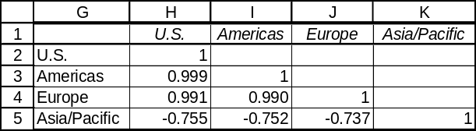

17.69 p/c/m The Minitab correlation table and the stepwise regression printout are shown below.
The correlations with operating cost per hour have also been included in the table. There are strong correlations between the pairs of independent variables, indicating the presence of multicollinearity.

Correlations: OpCost/Hr, Seats, Speed, Range, Gal/Hr

OpCost/Hr Seats Speed Range
Seats 0.849
0.000

Speed 0.668 0.855
0.000 0.000

Range 0.690 0.855 0.814
0.000 0.000 0.000

Gal/Hr 0.937 0.907 0.772 0.835
0.000 0.000 0.000 0.000

Cell Contents: Pearson correlation
P-Value

Stepwise Regression: OpCost/Hr versus Seats, Speed, Range, Gal/Hr

Alpha-to-Enter: 0.05 Alpha-to-Remove: 0.1

Response is OpCost/Hr on 4 predictors, with N = 33

Step 1 2
Constant 487.0 525.8

Gal/Hr 2.52 3.21
T-Value 14.97 11.77
P-Value 0.000 0.000

Range -0.68
T-Value -3.02
P-Value 0.005

S 819 729
R-Sq 87.85 90.68
R-Sq(adj) 87.45 90.06
Mallows Cp 10.9 3.6

Gal/Hr and Range are the only variables introduced. Following step 2, the estimation equation is simply OpCost/Hr = 525.8 +3.21*Gal/Hr - 0.68*Range, and it explains 90.68% of the variation in operating cost.

17.70 p/c/m The Minitab stepwise regression printout is shown below.

Stepwise Regression: %ofQuota versus Age, YrsFirm, NeatApp, AvgApp

Alpha-to-Enter: 0.05 Alpha-to-Remove: 0.1

Response is %ofQuota on 4 predictors, with N = 80

Step 1 2
Constant 78.97 93.06

YrsFirm 1.01 1.06
T-Value 4.17 4.48
P-Value 0.000 0.000

Age -0.35
T-Value -2.21
P-Value 0.030

S 17.0 16.6
R-Sq 18.25 23.13
R-Sq(adj) 17.20 21.14
C-p 7.2 4.2

The only two variables introduced are years with firm and age. The estimation equation is
%ofQuota = 93.06 + 1.06*YrsFirm - 0.35*Age. With age held constant, an additional year with the firm will tend to increase performance by 1.06 percentage points. With years with the firm held constant, an additional year of employee age will tend to reduce performance by 0.35 percentage points. The equation explains 23.13% of the variation in performance.

17.71 p/c/m
a. The Minitab correlation matrix is shown below. Multicollinearity might be a problem if all of the independent variables are used to estimate the final exam score. Test 1 is highly correlated to all of the other tests. In a stepwise regression, test 1 will be the first variable introduced since it has the highest correlation with the final exam score.

Correlations: FinalExam, Test1, Test2, Test3, Test4

FinalExa Test1 Test2 Test3
Test1 0.926
0.000

Test2 0.884 0.875
0.000 0.000

Test3 0.854 0.809 0.659
0.000 0.000 0.006

Test4 0.851 0.915 0.832 0.695
0.000 0.000 0.000 0.003

Cell Contents: Pearson correlation
P-Value

b. The Minitab stepwise regression is shown below.

Stepwise Regression: FinalExam versus Test1, Test2, Test3, Test4

Alpha-to-Enter: 0.05 Alpha-to-Remove: 0.1

Response is FinalExa on 4 predictors, with N = 16

Step 1
Constant 14.79

Test1 0.885
T-Value 9.15
P-Value 0.000

S 4.13
R-Sq 85.68
R-Sq(adj) 84.65
C-p 8.8

c. Test1 is the first variable brought into the regression, and no other variables are included.
The regression equation is FinalExam = 14.79 + 0.885*Test1. This regression explains 85.68% of the variation in the final exam score.
d. In the conventional simple regression analysis using only Test1, the output includes the standard deviation for the regression coefficient and the ANOVA table. The printout is shown below.

Regression Analysis: FinalExam versus Test1

The regression equation is FinalExam = 14.8 + 0.885 Test1

Predictor Coef SE Coef T P
Constant 14.792 7.437 1.99 0.067
Test1 0.88533 0.09674 9.15 0.000

S = 4.131 R-Sq = 85.7% R-Sq(adj) = 84.7%

Analysis of Variance
Source DF SS MS F P
Regression 1 1429.5 1429.5 83.75 0.000
Residual Error 14 239.0 17.1
Total 15 1668.4

17.72 p/c/m
b. The stepwise regression.

Stepwise Regression: Test1 versus Test2, Test3, Test4, FinalExam

Alpha-to-Enter: 0.05 Alpha-to-Remove: 0.1

Response is Test1 on 4 predictors, with N = 16

Step 1 2
Constant -3.412 -13.313

FinalExa 0.97 0.56
T-Value 9.15 3.46
P-Value 0.000 0.004

Test4 0.54
T-Value 3.00
P-Value 0.010

S 4.32 3.45
R-Sq 85.68 91.54
R-Sq(adj) 84.65 90.23
C-p 9.0 2.4

c. The first step introduces the final exam score. The equation is Test1 = -3.412 + 0.97*FinalExam.
This regression explains 85.68% of the total variation in the scores on test 1.
The second step includes test 4. The equation is Test1 = -13.313 + 0.56*FinalExam + 0.54*Test4.
This regression explains 91.54% of the total variation in the scores on test 1.

d. In the conventional regression analysis using only FinalExam and Test4, the output includes the standard deviation for the regression coefficient and the ANOVA table. The printout is below.

Regression Analysis: Test1 versus FinalExam, Test4

The regression equation is Test1 = - 13.3 + 0.557 FinalExam + 0.540 Test4

Predictor Coef SE Coef T P
Constant -13.313 7.727 -1.72 0.109
FinalExa 0.5569 0.1609 3.46 0.004
Test4 0.5404 0.1801 3.00 0.010

S = 3.446 R-Sq = 91.5% R-Sq(adj) = 90.2%

Analysis of Variance
Source DF SS MS F P
Regression 2 1669.39 834.70 70.30 0.000
Residual Error 13 154.36 11.87
Total 15 1823.75

17.73 p/c/m The Minitab stepwise regression printout is shown below. Although there are ten predictor variables, it takes only four of them to account for 100.00% (rounded) of the variation in passer ratings. The predictive equation is

Rating = 2.225 + 4.1793*YdsperAtt - 4.1763*Int_pct +3.3231*TD_pct + 0.8305*Comp_pct.

Stepwise Regression: Rating versus Atts, Comps, ...

Alpha-to-Enter: 0.05 Alpha-to-Remove: 0.1

Response is Rating on 10 predictors, with N = 32

Step 1 2 3 4
Constant 14.134 24.830 32.812 2.225

YdsperAtt 10.1003 10.3105 7.4311 4.1793
T-Value 7.86 11.25 8.73 472.64
P-Value 0.000 0.000 0.000 0.000

Int_pct -4.7854 -4.9357 -4.1763
T-Value -5.49 -7.88 -772.00
P-Value 0.000 0.000 0.000

TD_pct 3.1784 3.3231
T-Value 5.32 659.97
P-Value 0.000 0.000

Comp_pct 0.8305
T-Value 628.38
P-Value 0.000

S 5.21 3.71 2.66 0.0224
R-Sq 67.31 83.97 92.03 100.00
R-Sq(adj) 66.22 82.86 91.18 100.00
Mallows Cp 1434960.0 703690.2 349875.2 1.9

INTEGRATED CASES

THORNDIKE SPORTS EQUIPMENT

1. Simple linear regression.

Regression Analysis: Seconds versus YrCode

The regression equation is Seconds = 75.4 - 0.336 YrCode

Predictor Coef SE Coef T P
Constant 75.390 1.392 54.16 0.000
YrCode -0.33613 0.01893 -17.75 0.000

S = 1.04610 R-Sq = 94.9% R-Sq(adj) = 94.6%

Analysis of Variance
Source DF SS MS F P
Regression 1 344.90 344.90 315.17 0.000
Residual Error 17 18.60 1.09
Total 18 363.50

Unusual Observations
Obs YrCode Seconds Fit SE Fit Residual St Resid
1 54.0 59.400 57.239 0.423 2.161 2.26R
R denotes an observation with a large standardized residual.

2. Second-order polynomial regression.

Regression Analysis: Seconds versus YrCode, YrCode_Sq

The regression equation is Seconds = 90.5 - 0.756 YrCode + 0.00283 YrCode_Sq

Predictor Coef SE Coef T P
Constant 90.474 6.874 13.16 0.000
YrCode -0.7556 0.1887 -4.00 0.001
YrCode_Sq 0.002829 0.001268 2.23 0.040

S = 0.941660 R-Sq = 96.1% R-Sq(adj) = 95.6%

Analysis of Variance
Source DF SS MS F P
Regression 2 349.31 174.66 196.97 0.000
Residual Error 16 14.19 0.89
Total 18 363.50

Unusual Observations
Obs YrCode Seconds Fit SE Fit Residual St Resid
19 99.0 43.130 43.401 0.765 -0.271 -0.49 X
X denotes an observation whose X value gives it large leverage.

Predicted Values for New Observations
New
Obs Fit SE Fit 95% CI 95% PI
1 41.000 2.056 (36.642, 45.358) (36.207, 45.793)XX
XX denotes a point that is an extreme outlier in the predictors.

Values of Predictors for New Observations
New
Obs YrCode YrCode_Sq
1 115 13225

3. The second order polynomial model in part 2 explains R² = 96.1% of the variation in the times, compared to just 94.9% for the simple linear regression in part 1.
4. As shown in the printout in part 2, the estimated world record for the one-mile run in the year 2015 (YrCode = 115) is 41.000 seconds over 3 minutes, or a time of 3:41.00.

FAST-GROWING COMPANIES

1. The correlations seem to make sense -- e.g., there is a strong positive correlation (0.763) between the annual percentage return rate and the estimated price/earnings ratio a year from now.

Correlations: Earn/Share %, Net Income, Revenue%Grow, Revenue, ...

Earn/Share % Net Income Revenue%Grow Revenue
Net Income -0.107
Revenue%Grow 0.178 -0.156
Revenue -0.043 0.749 -0.110
Annual%Retur 0.068 0.021 -0.107 -0.077
StkPrice %Ch 0.044 -0.056 -0.113 -0.071
Stock Price -0.059 0.105 -0.139 0.055
Est P/E Rati 0.013 0.029 -0.046 -0.020
Tech -0.090 0.085 0.007 0.022
Industrial 0.075 -0.107 0.142 -0.066
Retail 0.094 -0.057 -0.099 0.047
Health -0.109 -0.056 -0.082 -0.072
Financial -0.116 -0.031 0.009 -0.056
Telecomm -0.065 0.026 -0.034 -0.063

Annual%Retur StkPrice %Ch Stock Price Est P/E Rati
StkPrice %Ch 0.734
Stock Price 0.696 0.777
Est P/E Rati 0.763 0.843 0.790
Tech 0.511 0.438 0.387 0.553
Industrial -0.200 -0.086 -0.219 -0.209
Retail -0.159 -0.135 -0.151 -0.174
Health -0.128 -0.113 0.074 -0.071
Financial -0.217 -0.144 -0.127 -0.154
Telecomm 0.086 -0.034 0.023 0.018

Tech Industrial Retail Health
Industrial -0.219
Retail -0.186 -0.116
Health -0.239 -0.149 -0.127
Financial -0.198 -0.123 -0.105 -0.134
Telecomm -0.198 -0.123 -0.105 -0.134

Financial
Telecomm -0.111

Cell Contents: Pearson correlation

2. Multiple regression analysis.

Regression Analysis: Stock Price versus Earn/Share , Net Income, ...

The regression equation is
Stock Price = 12.1 - 0.0217 Earn/Share %Growth + 0.0080 Net Income
- 0.0231 Revenue%Growth + 0.000500 Revenue + 0.191 Annual%Return
+ 0.0935 StkPrice %Change + 0.255 Est P/E Ratio - 8.06 Tech
- 6.27 Industrial - 0.4 Retail + 18.2 Health + 6.0 Financial
+ 0.1 Telecomm

96 cases used, 4 cases contain missing values

Predictor Coef SE Coef T P
Constant 12.11 10.27 1.18 0.242
Earn/Share %Growth -0.02167 0.02991 -0.72 0.471
Net Income 0.00798 0.01312 0.61 0.545
Revenue%Growth -0.02313 0.09055 -0.26 0.799
Revenue 0.0004997 0.0006645 0.75 0.454
Annual%Return 0.19138 0.07961 2.40 0.018
StkPrice %Change 0.09347 0.03476 2.69 0.009
Est P/E Ratio 0.25514 0.08879 2.87 0.005
Tech -8.057 9.459 -0.85 0.397
Industrial -6.272 9.763 -0.64 0.522
Retail -0.43 10.66 -0.04 0.968
Health 18.153 9.739 1.86 0.066
Financial 6.00 10.91 0.55 0.584
Telecomm 0.07 10.77 0.01 0.995

S = 24.9515 R-Sq = 73.0% R-Sq(adj) = 68.7%

Analysis of Variance
Source DF SS MS F P
Regression 13 138190 10630 17.07 0.000
Residual Error 82 51051 623
Total 95 189241

Qualitative variable 11 (technology) has a positive correlation (+0.387) with variable 8 (stock price), but its partial regression coefficient (-8.06) is negative. Likewise, qualitative variable 15 (financial services) has a negative correlation (-0.127) with variable 8 (stock price), but its partial regression coefficient (+6.0) is positive. In each case, the sign of the partial regression coefficient is the opposite of what it “should” be. This equation explains 73.0% of the variation in current stock price.

3. Stepwise regression.

Stepwise Regression: Stock Price versus Earn/Share , Net Income, ...

Alpha-to-Enter: 0.05 Alpha-to-Remove: 0.1

Response is Stock Price on 13 predictors, with N = 96
N(cases with missing observations) = 4 N(all cases) = 100

Step 1 2 3 4 5
Constant 15.897 18.411 15.598 9.724 7.839

Est P/E Ratio 0.554 0.332 0.321 0.255 0.234
T-Value 12.50 4.24 4.20 3.22 2.99
P-Value 0.000 0.000 0.000 0.002 0.004

StkPrice %Change 0.104 0.113 0.086 0.098
T-Value 3.36 3.72 2.72 3.09
P-Value 0.001 0.000 0.008 0.003

Health 18.4 19.9 21.0
T-Value 2.48 2.75 2.94
P-Value 0.015 0.007 0.004

Annual%Return 0.176 0.167
T-Value 2.45 2.37
P-Value 0.016 0.020

Net Income 0.0167
T-Value 2.02
P-Value 0.047

S 27.5 26.1 25.4 24.8 24.3
R-Sq 62.43 66.49 68.59 70.54 71.81
R-Sq(adj) 62.03 65.77 67.57 69.24 70.24
Mallows C-p 22.2 11.9 7.5 3.6 1.7

The stepwise regression brings in variables 9, 7, 14, 6, and 3: estimated P/E ratio a year from now, stock price percentage change, health industry affiliation, annual percentage revenue growth, and net income (in millions of dollars). The equation is
Stock Price = 7.839 + 0.234*Estimated P/E + 0.098*Stock Price Percentage Change
+21.0*Health Industry + 0.167*Annual Percentage Return rate
+ 0.0167*Net Income
A one-unit increase in the estimated P/E ratio would tend to increase the stock price by $0.234.
An increase of one percentage point in the stock price percentage change would tend to increase the current stock price by $0.098. If the company is in the health industry, the stock price would tend to be $21.0 higher than if it were in the “other” industrial category. An increase of one percentage point in the annual percentage return rate would tend to increase the current stock price by $0.167. An increase of one million dollars in the net income would tend to increase the current stock price by $0.0167.
The regression equation with these five independent variables explains 71.81% of the variation in current stock price, and this is only slightly less than the 73.0% explained by the regression in part 2 that used the entire set of independent variables.

BUSINESS CASES

WESTMORE MBA PROGRAM

1. As a first step in helping the committee members better understand how first-year MBA grade point average might be related to potential predictive variables, we will use Minitab to construct the correlation matrix below.

Correlations: GPA_Yr1, GMAT, UG_GPA, UG_Bus, UG_Tech, UG_1st5th, UG_2nd5th, ...

GPA_Yr1 GMAT UG_GPA UG_Bus UG_Tech UG_1st5th
GMAT 0.676
0.000

UG_GPA 0.627 0.504
0.000 0.000

UG_Bus -0.118 -0.043 -0.048
0.095 0.544 0.496

UG_Tech -0.055 0.229 -0.156 -0.520
0.438 0.001 0.026 0.000

UG_1st5th 0.271 0.369 0.154 -0.079 0.089
0.000 0.000 0.029 0.261 0.206

UG_2nd5th 0.134 0.246 0.081 0.032 -0.032 -0.317
0.057 0.000 0.250 0.656 0.647 0.000

UG_3rd5th -0.224 -0.236 -0.104 0.021 0.003 -0.328
0.001 0.001 0.140 0.769 0.972 0.000

UG_4th5th -0.054 -0.261 -0.103 0.031 -0.041 -0.165
0.449 0.000 0.146 0.666 0.558 0.019

Age -0.130 -0.306 -0.031 0.051 -0.059 0.029
0.065 0.000 0.658 0.475 0.404 0.679

US_Cit 0.045 0.042 -0.009 -0.028 0.081 0.113
0.521 0.552 0.903 0.694 0.251 0.108

UG_2nd5th UG_3rd5th UG_4th5th Age
UG_3rd5th -0.513
0.000

UG_4th5th -0.259 -0.267
0.000 0.000

Age -0.184 0.083 0.111
0.009 0.239 0.115

US_Cit -0.149 0.070 -0.062 0.026
0.034 0.322 0.383 0.710

Cell Contents: Pearson correlation
P-Value

Examining the correlation matrix, we find a number of independent variables that are strongly correlated to first-year MBA grade point average. GMAT score (r = 0.676) and undergraduate GPA
r = 0.627) are the two variables most strongly correlated with first-year MBA GPA. Each of these correlations differs very significantly from zero, with a p-value displayed as 0.000. Although the correlation between first-year MBA GPA and being in the first fifth of one’s undergraduate class also has a p-value of 0.000, in this case r = 0.271 does not reflect as much explanatory power as the two variables cited earlier. If the committee could choose only one variable in predicting first-year MBA GPA, we would recommend GMAT score. With r = 0.676 and r² = 0.46, this one variable explains 46% of the variation in first-year MBA GPA. Although the GMAT variable is highly explanatory and very significant, it still explains less than half of the variation in first-year MBA GPA. Also, Westmore could be subject to negative academic, political, and social scrutiny if it were to base its admission decisions solely on the basis of a single written-test variable.

2. Applying stepwise regression with first-year MBA GPA as the dependent variable. We will use Minitab, but for consistency with the results that would be obtained with Data Analysis Plus and Excel, we will select the alpha-to-enter and alpha-to-remove values (0.05 and 0.10, respectively) listed in the Minitab portion of Computer Solutions 17.6.

Stepwise Regression: GPA_Yr1 versus GMAT, UG_GPA, ...

Alpha-to-Enter: 0.05 Alpha-to-Remove: 0.1

Response is GPA_Yr1 on 10 predictors, with N = 202

Step 1 2 3 4 5
Constant 1.3923 1.0234 0.9310 0.9165 0.9996

GMAT 0.00311 0.00222 0.00238 0.00263 0.00287
T-Value 12.96 8.92 9.38 9.82 10.87
P-Value 0.000 0.000 0.000 0.000 0.000

UG_GPA 0.302 0.298 0.261 0.216
T-Value 7.10 7.11 5.98 4.98
P-Value 0.000 0.000 0.000 0.000

UG_4th5th 0.118 0.122 0.131
T-Value 2.51 2.63 2.93
P-Value 0.013 0.009 0.004

UG_Tech -0.100 -0.205
T-Value -2.60 -4.56
P-Value 0.010 0.000

UG_Bus -0.140
T-Value -4.12
P-Value 0.000

S 0.237 0.212 0.209 0.206 0.198
R-Sq 45.64 56.64 57.98 59.38 62.61
R-Sq(adj) 45.37 56.20 57.34 58.55 61.66
Mallows C-p 83.6 28.6 23.7 18.5 3.7

In the stepwise regression, five independent variables are introduced. As expected, GMAT was the first variable introduced, because it had the strongest correlation with the dependent variable, first-year MBA GPA, and this one variable explained 45.64% of the variation in first-year MBA GPA.
The second variable introduced was UG_GPA, undergraduate grade point average. At this second step, the predictive equation is

GPA_Yr1 = 1.0234 + 0.00222*GMAT + 0.302*UG_GPA, and it explains 56.64% of the variation in first-year MBA GPA.

The next three variables introduced increase explanatory power from 56.64% to 62.61% of the variation in first-year MBA GPA. The improvement is less than 6 percentage points compared to simply using the first two variables. Further, some of their coefficients suggest that multicollinearity has set in. In the correlation matrix, many of the independent variables are highly correlated with each other, and with p-values that are close to 0.000. At step 3, notice that UG_4th5th (being in the 4th 5th of one’s undergraduate class) is introduced and that it has a positive partial regression coefficient (0.118), despite the fact that the correlation matrix shows it to be negatively correlated (r = -0.054) with first-year MBA GPA. The sign of the partial regression coefficient is the opposite of what it “should” be, a typical indicator of multicollinearity.
Regarding the variables introduced in steps 4 and 5 (UG_Tech and UG_Bus), their partial regression coefficients are negative, as are their respective coefficients of correlation with first-year MBA GPA. However, the correlation matrix shows that each is negatively correlated with UG_GPA. It may be that technical and business undergraduate programs are more demanding than other majors and grade point averages for these programs naturally tend to generate lower grade point averages.

3. Although a multiple regression using all of the independent variables would suffer from multicollinearity and make interpretation of the partial regression coefficients quite suspect, we will apply this approach strictly for the purpose of determining how much of the variation in first-year MBA GPA could be explained by such a model. The resulting printout is shown below. Although several of the partial regression coefficients have signs that are opposite that of their respective coefficients of correlation with the dependent variable, the package of all 10 predictor variables explains 63.1% of the variation in first-year MBA GPA. This is a relatively small improvement versus the 56.64% explanatory percentage obtained by simply using the GMAT and UG_GPA predictors, and (perhaps most importantly) its implementation by Westmore’s admissions committee could lead to some problems if the formula were to become known to program applicants or to local, state, or national media. For example, predicting a higher first-year MBA GPA for persons in the 4th 5th of their undergraduate class would not reflect very positively on Westmore and their commitment to building a quality MBA program.

Regression Analysis: GPA_Yr1 versus GMAT, UG_GPA, ...

The regression equation is
GPA_Yr1 = 0.751 + 0.00288 GMAT + 0.212 UG_GPA - 0.142 UG_Bus - 0.209 UG_Tech
+ 0.0393 UG_1st5th + 0.0278 UG_2nd5th + 0.0180 UG_3rd5th
+ 0.153 UG_4th5th + 0.00826 Age + 0.0398 US_Cit

Predictor Coef SE Coef T P
Constant 0.7507 0.2635 2.85 0.005
GMAT 0.0028829 0.0003409 8.46 0.000
UG_GPA 0.21164 0.04543 4.66 0.000
UG_Bus -0.14176 0.03454 -4.10 0.000
UG_Tech -0.20944 0.04624 -4.53 0.000
UG_1st5th 0.03932 0.09658 0.41 0.684
UG_2nd5th 0.02781 0.08930 0.31 0.756
UG_3rd5th 0.01802 0.08408 0.21 0.831
UG_4th5th 0.15341 0.08902 1.72 0.086
Age 0.008258 0.007866 1.05 0.295
US_Cit 0.03981 0.04041 0.99 0.326

S = 0.199315 R-Sq = 63.1% R-Sq(adj) = 61.2%

Analysis of Variance
Source DF SS MS F P
Regression 10 12.9921 1.2992 32.70 0.000
Residual Error 191 7.5877 0.0397
Total 201 20.5798

Even using this full regression model, 36.9% of the variation in first-year MBA GPA would be unexplained. Some other quantitative or nonquantitative variables that might help reduce the unexplained variation might be family income, education level of one’s parents, physical appearance, personality, work ethic, ability to work with others in team-based projects that are typically employed in MBA courses, as well as other personal characteristics such as general mental and physical health.

Based on these analyses, it would seem both statistically and politically desirable to use only the first two variables that were introduced in the stepwise regression -- GMAT and UG_GPA. They offer good explanatory power and they are not subject to outside criticisms such as might arise from a model that predicts higher first-year MBA GPA values for persons in the 4th 5th of their undergraduate class, or from a full model like the one above that provides lower predictions for undergraduate technology or business majors and higher predictions for persons who are older or who are not U.S. citizens.
The Committee may wish to consider expressing the equation as an applicant index score.
For example, instead of simply calculating GPA_Yr1 = 1.0234 + 0.00222*GMAT + 0.302*UG_GPA, they might consider eliminating the constant in the equation (since it is the same for all applicants) and evaluating each applicant on the basis of an expression such as

Applicant Index Score = 0.222*GMAT + 30.2*UG_GPA

In such an applicant index score, we have merely eliminated the constant and multiplied each partial regression coefficient by 100 to make the expression more visually appealing. Westmore’s next step would be to establish a cutoff index score to determine which applicants to accept and which to reject. Naturally, the committee’s choice of a specific numerical cutoff score would have to strike a balance between student quality and enrollment total, two entities that have a tendency to be inversely related.

The scatter diagram below demonstrates the positive relationship between the preceding “Applicant Index Score” and first-year MBA GPA, and the accompanying dotplot displays the “Applicant Index Score” values for the MBA students in the database. By drawing a vertical line at any given point along the dotplot, we can get some insights into the percentage of current students who would have been rejected if this particular cutoff had been in effect when they applied.
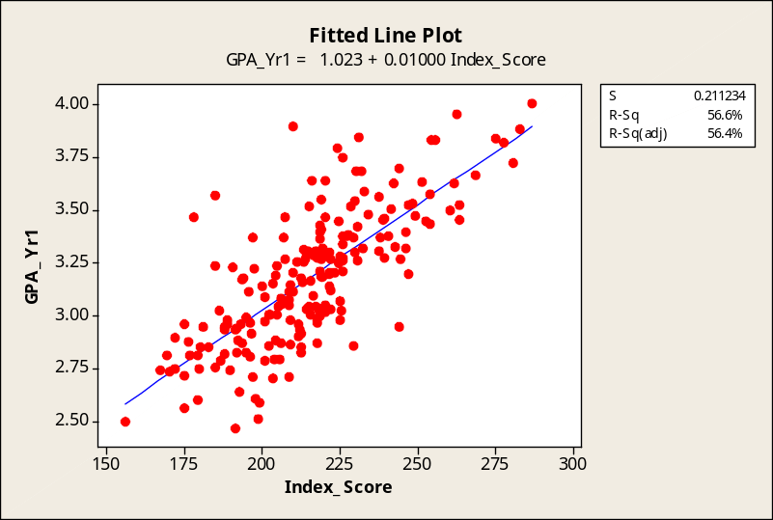

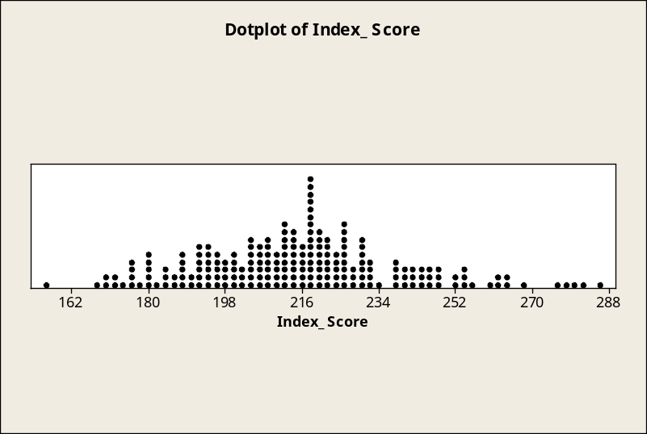

EASTON REALTY COMPANY (B)

1. As a first step in helping Sam Easton better understand how the sales price of a residential property is determined, we will construct a correlation matrix for the variables Price, SqFeet, Bedrooms, Age, Dallas, and Easton. Recall that the Dallas variable is coded as 1 for homes located in Dallas and as 0 for those located elsewhere. Likewise, Easton = 1 for homes sold by Easton, and Easton = 0 for those sold by other realtors.

Correlations: Price, SqFeet, Bedrooms, Age, Dallas, Easton

Price SqFeet Bedrooms Age Dallas
SqFeet 0.716
0.000

Bedrooms 0.434 0.673
0.000 0.000

Age -0.020 0.033 0.068
0.701 0.517 0.186

Dallas 0.557 -0.067 -0.135 -0.084
0.000 0.196 0.008 0.102

Easton -0.070 0.063 0.063 0.013 -0.196
0.177 0.225 0.222 0.799 0.000

Cell Contents: Pearson correlation
P-Value

Examining the correlation matrix, we find that the independent variable with the strongest correlation with Price is SqFeet, with a correlation coefficient of 0.716. The variable having the second strongest correlation is Dallas, having a correlation coefficient of 0.557. The third strongest correlation coefficient with Price is Bedrooms, with a correlation of coefficient of 0.434. Each of these coefficients differs very significantly from zero, with each p-value expressed as 0.000. Neither Age nor Easton has a significant coefficient of correlation, and each of these correlation coefficients is very close to zero.

2. Applying stepwise regression with Price as the dependent variable. We will use Minitab, but for consistency with the results that would be obtained with Data Analysis Plus and Excel, we will select the alpha-to-enter and alpha-to-remove values (0.05 and 0.10, respectively) listed in the Minitab portion of Computer Solutions 17.6.

Stepwise Regression: Price versus SqFeet, Bedrooms, Age, Dallas, Easton

Alpha-to-Enter: 0.05 Alpha-to-Remove: 0.1

Response is Price on 5 predictors, with N = 378

Step 1 2
Constant 22325 8883

SqFeet 37.02 39.11
T-Value 19.88 42.14
P-Value 0.000 0.000

Dallas 21208
T-Value 33.84
P-Value 0.000

S 12161 6048
R-Sq 51.25 87.97
R-Sq(adj) 51.12 87.91
Mallows C-p 1135.6 0.4

In the stepwise regression, only two independent variables were introduced, SqFeet and Dallas, and they explain 87.97% of the variation in home prices. As expected, SqFeet was the first variable introduced, because it had the strongest correlation with the dependent variable, Price. Although Bedrooms had a strong correlation with Price, Bedrooms also had a strong correlation with SqFeet -- both of these variables are basically expressing “bigness,” so Bedrooms is not judged by the stepwise model as explaining an important portion of the 12.03% of the variation in Prices that remains unexplained. Not surprisingly, the other explanatory variable introduced was Dallas. As we have seen in our analysis of Easton Realty Company (A) at the end of Chapter 16, homes sold in the Dallas area tended to command a hefty price premium over those sold elsewhere.

3. For a conventional Minitab regression equation with only SqFeet and Dallas as predictor variables, only 12% (rounded) of the variation in Price is shown as remaining unexplained. There are many other quantitative and nonquantitative variables that could help explain this remaining variation. For example, a location next to a fire station or noisy nightclub could reduce the value of a home, while a location near a golf course or recreation area could enhance the value. Also, variables such as recent home improvements, scenic picture-window views, or the presence of a backyard swimming pool or jacuzzi could influence the selling price of a home. The conventional regression analysis below utilizes only the two variables that were included in the stepwise regression. The equation and the explanatory power remain the same (subject only to differing numbers of decimal places being displayed), and only the format of the printout has changed versus the stepwise regression carried out previously.

Regression Analysis: Price versus SqFeet, Dallas

The regression equation is Price = 8883 + 39.1 SqFeet + 21208 Dallas

Predictor Coef SE Coef T P
Constant 8883 1799 4.94 0.000
SqFeet 39.1084 0.9281 42.14 0.000
Dallas 21208.3 626.7 33.84 0.000

S = 6048.34 R-Sq = 88.0% R-Sq(adj) = 87.9%

Analysis of Variance
Source DF SS MS F P
Regression 2 1.00337E+11 50168549511 1371.38 0.000
Residual Error 375 13718410740 36582429
Total 377 1.14056E+11

